TECHNICAL REPORT

LISBON VALLEY EAST PROPERTY

Located in San Juan County, Utah, USA

Big Indian Mining District
Meridan 26 Townships 029S, 030S Ranges 024E, 025E
657800E 4232500N NAD83 Zone 12

FOR

American Atomics Inc.
1500 - 1055 West Georgia Street
Vancouver BC CANADA V6E 4N7

R. Tim Henneberry, P.Geo.
2026-Mar-27

-2-
SUMMARY

American Atomics Inc. is exploring the 4,466 acre (1,807.3 hectare) Lisbon Valley East ("LVE") project for penecordant uranium mineralization in Moss Back Member sandstones and conglomerates at the base of the Triassic Chinle Formation in the Colorado Plateau uranium region of the Four Corners area of the southwestern United States. LVE lies approximately 35 miles (56 kilometers) southeast of Moab, Utah and consists of 217 Bureau of Land Management (BLM) lode claims.

American Atomics can earn up to an 80% interest in the LVE project (the “Property Interest”) by completing a series of work commitments, cash payments and share and warrant issuances over the next five years, consisting of: US$18,000,000 in exploration expenditures, US$1,500,000 in cash payments, US$4,800,000 in shares, and 3,000,000 five year warrants with a Cdn$0.50 strike price. There are no royalties.

Lisbon Valley produced approximately 80 million pounds of U₃O₈ between 1950 and 1990 from an arcuate belt some 16 miles long by 1 mile wide with approximately 1/3 of the belt eroded away post mineral. Individual ore bodies ranged from a few hundred pounds to 20,000,000 pounds of U₃O₈, hosted in the basal Moss Back Member of the Triassic Chinle Formation along the southwest flank of the Lisbon Valley anticline. A northwest trending, post-mineral normal fault, the Lisbon Valley Fault, abruptly cut-off and displaced the uranium mineralization associated with the northeast flank, speculatively dropping it + 2500 feet on the northeast side of the fault.

The Lisbon Valley East property was staked targeting the suspected arcuate uranium belt on the downfaulted northeastern side of the Lisbon valley anticline, which the author believes lies at 2500 to 2800 feet below surface based on the following factors:

- The North Alice ore body at the north end of the southwestern arcuate uranium belt ends abruptly at the Lisbon Valley fault, not due to a drop in grade or mineralization, but due to fault displacement, strongly suggesting uranium mineralization continued pre-fault.
- The Rio Algom mine was subsequently discovered on the down-dropped footwall side of the fault, which Lahusen (1977) speculated was the actual continuation of the North Alice ore body. The North Alice orebody produced 6,000,000 pounds of U₃O₈ at a grade of 0.25% U₃O₈ (Lahusen, 1977), while the Lisbon Valley mine produced 13,000,000 pounds of U₃O₈ at the same 0.25% U₃O₈ grade (Chenoweth, 1990).
- Drilling by Mesa Uranium Corp. and Universal Uranium Ltd. in the 2006 and 2007 period located anomalous uranium mineralization at the base of Chinle Formation in the Moss Back Member, with one highlight 3.5 foot intersection of 0.28% U₃O₈, further proving the Moss Back Member is uranium-bearing on the down faulted side on the anticline.
- Oil and gas drilling in the 2000’s and early 2010’s on the northeast down-faulted side of the Lisbon Valley anticline located anomalous to extremely anomalous gamma ray readings in the suspected Moss Back Member in 28 of 51 hole drilled throughout a northwest trending belt 20 kilometres in length by + 750 metres in width, outlining the suspected eastern arcuate belt.

An exploration program of verification drilling of the key oil and gas Moss Back gamma ray anomalies is very much warranted to commence the confirmation of a suspected second arcuate uranium belt at Lisbon Valley, associated with the northeast side of the Lisbon Valley anticline. A 28,000 foot drilling program consisting of 10 holes, focused on testing the key oil and gas gamma ray anomalies is recommended at a cost of US$3,000,000.
-3-
TABLE OF CONTENTS

SUMMARY 3
INTRODUCTION 5
RELIANCE ON OTHER EXPERTS 5
PROPERTY DESCRIPTION AND LOCATION 6
ACCESSIBILITY, CLIMATE, LOCAL RESOURCES, INFRASTRUCTURE AND PHYSIOGRAPHY 9
HISTORY 8
Mesa Uranium 2006-2008 12
Universal Uranium 2006-2008 14
Utah Oil and Gas Database 15
GEOLOGICAL SETTING AND MINERALIZATION 20
Geologic History 22
Salt Anticlines 24
Local Geology 25
Mineralization 28
DEPOSIT TYPES 33
EXPLORATION 33
DRILLING 33
SAMPLE PREPARATION, ANALYSES AND SECURITY 33
DATA VERIFICATION 33
MINERAL PROCESSING AND METALLURGICAL TESTING 34
MINERAL RESOURCESAND MINERAL RESERVE ESTIMATES 34
ADJACENT PROPERTIES 34
OTHER RELEVANT DATA AND INFORMATION 34
INTERPRETATION AND CONCLUSIONS 34
RECOMMENDATIONS 35
REFERENCES 36
CERTIFICATE OF QUALIFIED PERSON 37

LIST OF FIGURES
Figure 1: Lisbon Valley East Location 5
Figure 2: Lisbon Valley East Area Location 6
Figure 3: Lisbon Valley East Property Claim Map 9
Figure 4. Mesa Uranium 2006/2007 Drilling 13
Figure 5: Universal Uranium 2006/2007 Drilling 14
Figure 6: Utah Oil and Gas Drilling 16
Figure 7: Anomalous Gamma Ray from Select Lisbon Valley Utah Oil and Gas Drill Holes 20
Figure 8: Stratigraphic Column of the Colorado Plateau (from Hall et al, 2023) 21
Figure 9: Geology of the Lisbon Valley Area (from Doelling, 2004) 23
Figure 10: Lisbon Valley Mineralization 30

-4-

LIST OF TABLES
Table 1: Lisbon Valley Historic U₃O₈ Production 11
Table 2: Mesa Uranium 2006-2007 Lisbon Valley East Drill Results 12
Table 3: Universal Uranium 2006 Lisbon Valley East Drill Results 15
Table 4: Utah Oil and Gas Drill Hole Database Chinle Formation Gamma Ray Results 18
Table 4a: Utah Oil and Gas Drill Hole Key Intersection Northing and Easting Coordinates 19
Table 5: Lahusen (1977) Table 1. Chinle Formation Production from Lisbon Valley District Mines 1948-1977 27
Table 6. Lahusen (1977) Figure 7 – Comparisons of Tons U₃O₈ discovered per Linear Mile 28

APPENDIX
Appendix 1: List of BLM Unpatented Mineral Claims 36

-5-

INTRODUCTION

This technical report is being prepared at the request of American Atomics Inc. to support the acquisition of the Lisbon Valley Project announced October 27, 2025. The technical information included in this report is drawn from sources believed to be reliable by the author, namely government publications and government-maintained databases, as well as reports completed by industry professionals both prior to and since the implementation of National Instrument 43-101. The bulk of these sources are given in the references section of this technical report.

The author has visited the Lisbon Valley area, including the Lisbon Valley East property on several occasions over the last few years, including: 2023-Jul-21, 2024-Jan-19 and 2024-Apr-23 and most recently 2025-Jul-26 and 2025-Jul-27. The author looked at the Chinle Formation where it outcrops to the west of the property and also looked at the general topography and road access as the uranium target formation is + 2,500 feet below surface.

RELIANCE ON OTHER EXPERTS

The author is not relying on any experts for this technical report. The author accessed the claim information from the Bureau of Land Management Mineral & Lands Record System (MLRS) maintained by the US Federal Government to confirm claim ownership and current status.

Figure 1. Lisbon Valley East Location
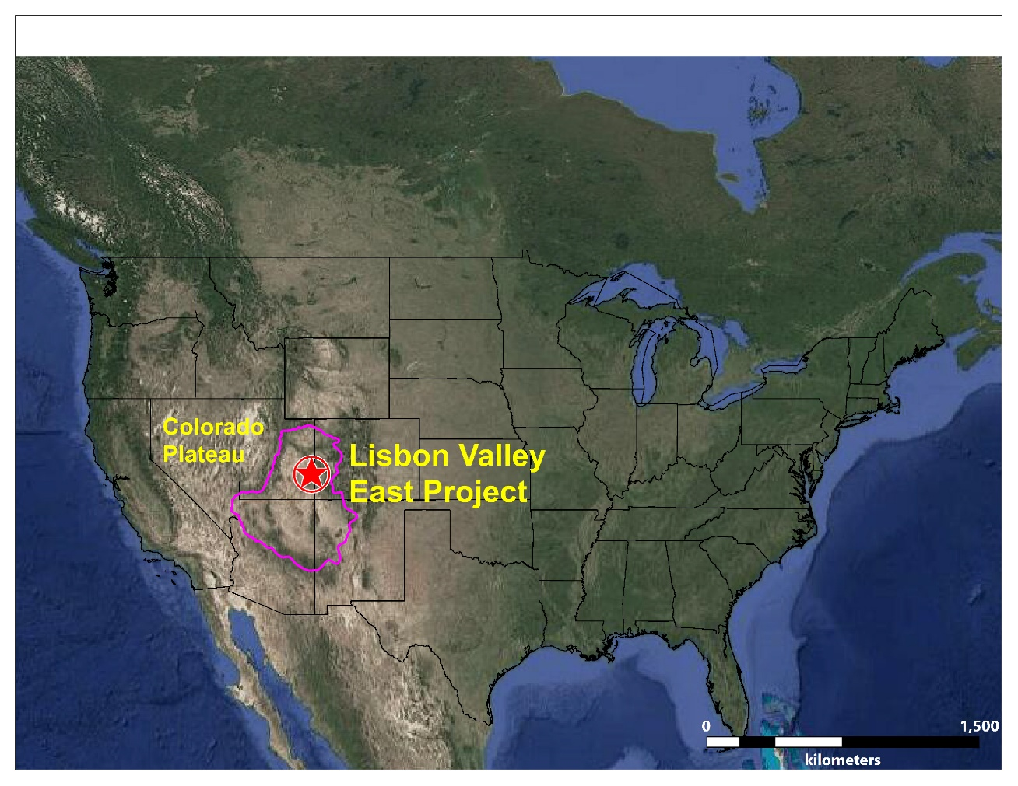

-6-
PROPERTY DESCRIPTION AND LOCATION

The Lisbon Valley East property lies approximately 35 miles (56 kilometres) southeast of Moab, Utah and consists of 217 Bureau of Land Management (BLM) lode claims totaling 4,466 acres (1,807.3hectares), numbered DBI 1 through DBI 217 (Serial Numbers UT106370564 through UT106370780). The claims lie in San Juan County within Township 29 South through Township 30 South and Range 23 East through Range 26 East, Salt Lake Meridian. The specific sections in each of these Townships and Ranges where the claim are located can be found in the complete table of claims in Appendix I. Federal BLM claims need to renewed by September 1 of each year with fees due to both the BLM and the county. The claims are currently in good standing until September 1, 2026.

Figure 2. Lisbon Valley East Area Location
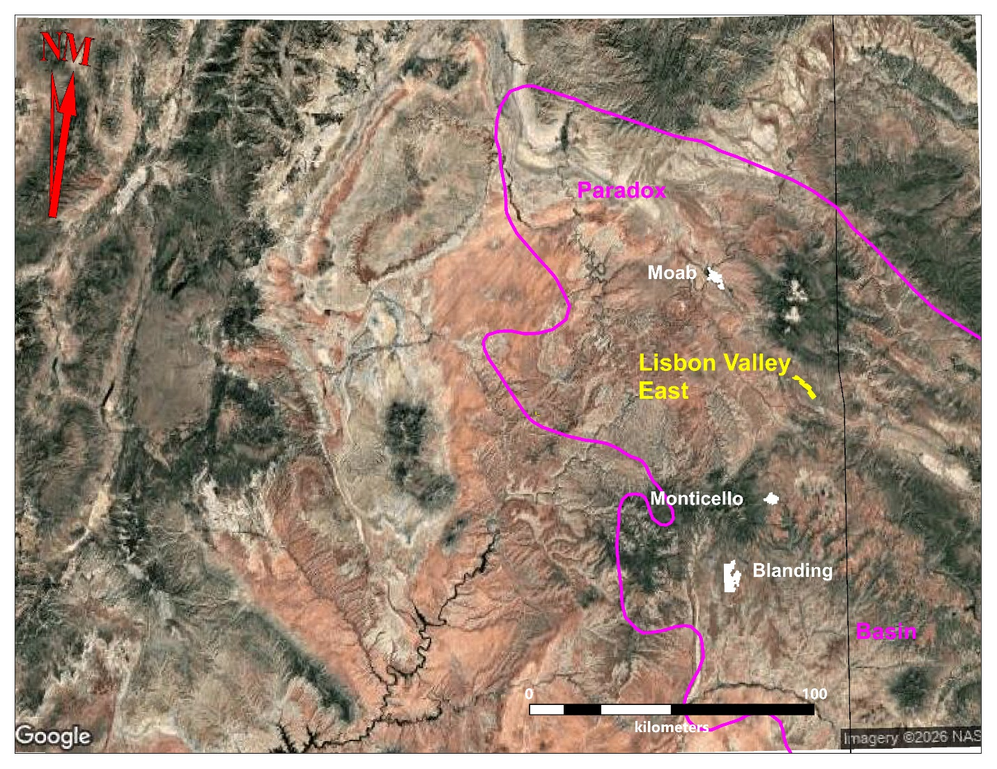

All 217 claims were staked by location by the property Vendor, Big Indian Prospectors LLC.

-7-

On March 10, 2026, American Atomics Inc. entered into an option agreement (the “Option Agreement”) to earn up to an 80% interest in the DBI claims by making US$ cash payments and share issuances along and completing annual work commitments as follows:
- making an aggregate of $1,500,000 in cash payments to Big Indian Prospectors LLC (the 'Option Payments') as follows :
- $20,000 on signing of the Letter of Intent (October 23, 2025); (paid)
- $130,000 on March 10, 2026; (paid)
- $150,000 on or before the commencement date of Earn-In Year I (as defined in the Option Agreement);
- $550,000 on or before the commencement date of Earn-In Year 2;
- $650,000 on or before the commencement date of Earn-In Year 3;

- Subject to the approval of the Exchange, issuing to Big Indian Prospectors LLC an aggregate of $4,800,000 of common shares in the capital of American Atomics Inc. (the "Option Shares"), with each issuance subject to a Hold Period, as follows:
- $300,000 of common shares within ninety (90) days from the Permit Date (as defined below);
- $1,300,000 of common shares on or before the commencement date of Earn-In Year I;
- $1,500,000 of common shares on or before the commencement date of Earn-In Year 2;
- $1,700,000 of common shares on or before the commencement date of Earn-In Year 3;

- Subject to the approval of the Exchange, issuing to Big Indian Prospectors LLC 3,000,000 common share purchase warrants ("Option Warrants'') within five (5) days from March 10, 2026 in accordance with Section 5.8 of the Option Agreement; and

- incurring an aggregate of $18,000,000 in Expenditures on the Property throughout all Earn-In Years (the "Expenditure Commitments"), to be spent as follows for each applicable Earn-In Year:
- $3,600,000 on or before the commencement date of Earn-In Year I for 40% of the Property Interest;
- $3,600,000 on or before the commencement date of Earn-In Year 2 for an additional 10% of the Property interest;
- $3,600,000 on or before the commencement date of Earn-In Year 3 for an additional 10% of the Property interest;
- $3,600,000 on or before the commencement date of Earn-In Year 4 for an additional 10% of the Property Interest;
- $3,600,000 on or before the commencement date of Earn-In Year 5 for an additional 10% of the Property Interest.

The Permit Date is the date American Atomics receives a permit to drill at Lisbon Valley from the Bureau of Land Management. Each Earn-In Year is the anniversary of the Permit Date.

-8-

The Option Shares shall be issued at prices per shares dependent on current trading prices and the policies of the Exchange, and shall be subject to approval of the Exchange. The number of common shares issuable as Option Shares or as a Substitution Payment shall be the applicable dollar amount divided by the greater of (X) the 30 trading-day volume-weighted average price of American Atomics Inc.'s common shares on the Exchange ending two (2) trading days prior to the issuance date (converted to U.S. dollars at the Bank of Canada daily exchange rate published for such date), and (Y) the minimum price per share permissible by the Exchange (converted to U.S. dollars at the Bank of Canada daily exchange rate published for such date). Any common shares issued hereunder shall be subject to a Hold Period.

The Option Warrants shall be exercisable at CDN $0.50 per common share and shall have a term of five (5) years from the date of issuance. The Option Warrants shall be subject to applicable securities laws and Exchange Policies, including a Hold Period, and shall vest in tranches as follows: (i) 300,000 Option Warrants vest ninety (90) days after the Permit Date; (ii) 850,000 Option Warrants vest on the first (1st ) anniversary of the Permit Date; (iii) 850,000 Option Warrants vest on the second (2nd anniversary of the Permit Date: and (iv) 1,000,000 Option Warrants vest on the third (3rd) anniversary of receipt of the Permit Date. Any unvested Option Warrants shall expire upon termination of this Agreement in accordance with Section 11 of the Option Agreement.

Upon completion of the cash payments, share issuances and exploration expenditures a joint venture will be formed with Big Indian Prospectors LLC. required to meet 20% of post-completion exploration costs to maintain its interest or be subject to dilution of its interest by a set agreed upon formula.

At such time as Big Indian Prospectors LLC's interest in the Property is reduced to 10% , American Atomics Inc. shall pay the Big Indian Prospectors LLC's unfunded contributions going forward, and such contributions shall be credited to a carried capital account at 125% the amount of actual contributions, and which will be subject to an annual interest charge of a mutually agreed upon interest rate benchmark plus 3%; eighty percent (80%) of distributions to Big Indian Prospectors LLC shall be used for repayment of the carried account (to American Atomics Inc.) until paid in full.

There are no royalties on the property and no other encumbrances on the property to the best of the author’s knowledge.

The next stage of exploration on the Lisbon Valley East property is drilling. A permit will be required from the Bureau of Land Management. The intent of American Atomics will be to apply under the Notice of Intent provision which limits disturbance to a maximum of 5 acres. A performance bond will be required before the permit will be issued. The Lisbon Valley East property lies in an active oil and gas field with widely spaced producing and abandoned drill holes throughout the claim group and in the general area, so permitting is not expected to be an issue. To the best of the author’s knowledge, there are no other significant factors or risks that may affect access, title, or the right or ability to perform work on the property.

-9-
ACCESSIBILITY, CLIMATE, LOCAL RESOURCES, INFRASTRUCTURE AND PHYSIOGRAPHY

The road accessible Lisbon Valley East project lies approximately 35 miles (56 kilometers) southeast of Moab or 20 miles (32 kilometers) northeast of Monticello in southeast Utah. Access is as follows: from Moab continue 20 miles (32 kilometers) south on Highway 191 to La Sal Junction and then east on highway 46 a distance of 6 miles (10 kilometers) to Lisbon Valley Road. From the junction of Highway 46 and Lisbon Valley Road, travel south on Lisbon Valley Road to the junction with Big Indian Road. The claims lie 3 miles (5 kilometers) south of this junction. The nearest commercial airport lies in Grand Junction, Colorado, approximately 130 road miles (209 kilometers) from the project area. Services can be found in both Moab and Monticello, and a labor pool of mining and milling personnel exists in the region.

Figure 3. Lisbon Valley East Property Claim Map
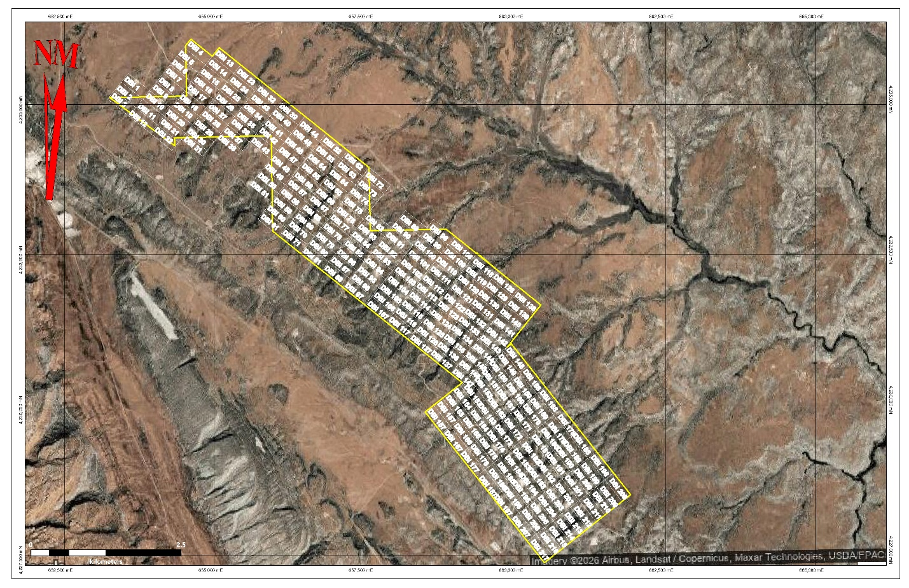

Topography ranges from 6,000 feet (1,828 meters) to a high of 7,000 feet (2,133 meters) elevation on the northeastern side of Lisbon valley, one of several northwest trending stream valleys along anticlinal structures that resulted from salt dome formation through the Paradox Basin. Average daily temperatures in the winter months are in the 40’s and 50’s (4 to 10 Celsius) and in the summer months are in the 90’s (mid 30's Celsius).

-10-

The Lisbon Valley area has a semi-arid climate characterized by large daily and yearly ranges in temperature, with a total annual precipitation of about 10 to 15 inches (25 to 38 centimeters), mostly as sporadic, intense thundershowers typical of the high desert Colorado Plateau. Snow is infrequent at altitudes below 6,500 feet (1,981 meters) and usually melts in a few days. Weather conditions pose no inhibition to year-round work on the property.

Vegetation in the project area consists of sagebrush, juniper and pinyon in the hills and slopes while desert grasses and sagebrush sparsely cover the Lisbon Valley floor.

Lisbon Valley East is a drilling stage exploration project as the target drilling depth is + 2,500 feet below the present ground surface, so it is premature to comment on potential tailings storage areas, potential waste disposal areas, heap leach pad areas, and potential processing plant sites at this time. However, this is an active industrial area with a history of uranium mining and oil drilling and pumping. It is serviced by an electrical grid and water would need to be sourced from wells.

HISTORY

The history of the Lisbon Valley is taken directly from Chenoweth (1990), who was employed by the U.S. Atomic Energy Commission (AEC) and succeeding agencies, the U.S. Energy Research and Development Administration, and the U.S. Department of Energy (DOE).

Uranium ore deposits in the Lisbon Valley area are in a arcuate belt, 16 miles long by one mile wide, on the southwestern flank of the Lisbon Valley anticline. The principal host rock is the Moss Back Member of the Triassic Chinle Formation. Significant orebodies also occur in the underlying Permian Cutler Formation. Although small oxidized deposits occurred in the area, wildcat drilling by a single individual in 1952 discovered a major unoxidized deposit. The following surge of exploration drilling discovered most of the deposits by 1956.

Annual ore production reached a record high in 1959 when over 6.6 million pounds U₃O₈ were produced, but production declined there after due to ore purchase restrictions by the U.S. Atomic Energy Commission (AEC). When the AEC program ended in 1970, Lisbon Valley had produced 53.6 million pounds U₃O₈, which represented 12 percent of the total uranium produced in the United States during the 1948-1970 period. The majority of the ore was processed at a mill in Moab, Utah.

Wildcat drilling in 1964 and 1965 on the northwestern nose of the anticline discovered ore on the down dropped, northeast side of the Lisbon Valley fault. This deep, + 2,500 foot discovery lead to the development of the Lisbon mine and mill which began producing in 1972. High uranium prices and a strong market in the mid-1970's were responsible for a second boom in the area, and several additional deposits were discovered including a major deposit in the Cutler Formation in the southwestern part of the area.

Declining prices and a weak market in the early 1980's forced many of the mines and the Moab mill to close in early 1984, and the Lisbon mine and mill to close in late 1988. During the 41 years, 1948-1988, that the uranium mines in Lisbon Valley were operating, a total of 12,778,662 tons of ore containing 77,913,378 pounds of U₃O₈ were produced.
-11-

Considerable exploration efforts have been directed at the downthrown eastern side of the Lisbon Valley fault, looking for a similar arcuate belt suspected to be associated with the northeast side of the Lisbon Valley anticline. The Rio Algom Mine discovered at 2,500 feet (762 meters) in 1964-1965 proved the Chinle Formation was uraniferous on the northeastern side of the Lisbon Valley fault producing some 13 million pounds of U₃O₈ at an average grade of 0.25% (Chenoweth, 1990).

Table 1. Lisbon Valley Historic U₃O₈ Production
Year | Tons | ibs U3O8 | % U3O8 |  | Year | Tons | ibs U3O8 | % U3O8
1948 | 888 | 2,768 | 0.16 |  | 1971 | 349,397 | 1,290,617 | 0.18
1949 | 37 | 244 | 0.30 |  | 1972 | 340,605 | 1,293,100 | 0.19
1950 | 31 | 104 | 0.17 |  | 1973 | 384,722 | 1,886,084 | 0.25
1951 | 392 | 1,361 | 0.17 |  | 1974 | 408,706 | 1,721,352 | 0.21
1952 | 537 | 2,499 | 0.23 |  | 1975 | 376,365 | 1,448,034 | 0.19
1953 | 50,957 | 458,738 | 0.45 |  | 1976 | 517,053 | 1,629,184 | 0.16
1954 | 187,600 | 1,178,300 | 0.31 |  | 1977 | 410,659 | 1,619,316 | 0.20
1955 | 334,122 | 2,567,695 | 0.38 |  | 1978 | 503,863 | 1,531,872 | 0.15
1956 | 502,313 | 3,666,431 | 0.36 |  | 1979 | 429,256 | 1,495,463 | 0.17
1957 | 641,386 | 5,034,429 | 0.39 |  | 1980 | 431,335 | 2,587,860 | 0.30
1958 | 774,911 | 6,416,891 | 0.41 |  | 1981 | 408,057 | 2,510,460 | 0.31
1959 | 814,619 | 6,687,646 | 0.41 |  | 1982 | 263,998 | 1,722,965 | 0.33
1960 | 668,064 | 4,447,743 | 0.33 |  | 1983 |  | 573,750
1961 | 660,018 | 4,061,834 | 0.31 |  | 1984 |  | 784,800
1962 | 439,672 | 3,891,689 | 0.44 |  | 1985 | 769,800 | 593,006 | 0.23
1963 | 455,464 | 4,209,658 | 0.46 |  | 1986 |  | 656,300
1964 | 494,048 | 4,686,113 | 0.47 |  | 1987 |  | 589,000
1965 | 167,648 | 1,327,241 | 0.40 |  | 1988 |  | 344,100
1966 | 70,360 | 612,597 | 0.44 |  | 1971-1988 | 5,593,816 | 24,277,263 | 0.22
1967 | 141,788 | 884,559 | 0.31
1968 | 266,965 | 1,254,731 | 0.23
1969 | 201,715 | 828,518 | 0.21 |  | 1948-1970 | 7,189,846 | 53,636,121 | 0.37
1970 | 316,311 | 1,414,332 | 0.22 |  | 1971-1988 | 5,593,816 | 24,277,263 | 0.22
1948-1970 | 7,189,846 | 53,636,121 | 0.37 |  | Total | 12,783,662 | 77,913,384 | 0.30

The Lisbon Valley production is taken from Chenoweth (1990). He noted the following with respect to the yearly production figures: The 1948 – 1970 production figures are sourced from unpublished resource area production records from the U. S. Atomic Energy Commission, Grand Junction, Colorado office. The 1971 – 1982 production figures are sourced from unpublished resource area production records from the U.S. Department of Energy, Grand Junction, Colorado office. The 1983 – 1988 production figures are sourced from data provided by Atlas Minerals Division and Rio Algom Corporation.

-12-

The suspected Eastern Arcuate Belt has remained an enticing target, with exploration directed at this target during each uranium cycle. Drilling continued to search further to the northeast of the Lisbon Valley fault, both prior to and since the discovery of the Lisbon Valley mine, timed with the uranium cycle booms. However, while exploration has continued on the east side of the Lisbon Valley fault, records from the earlier periods are not generally in the public record. During the recent 2005 to 2007 cycle, two junior miners directed significant effort at the target: Mesa Uranium Corp. and Universal Uranium Ltd.

Mesa Uranium 2006-2008
Mesa Uranium held over 16,500 acres (6,700 hectares) during the 2005 to 2008 period, covering approximately 4.4 miles (7 kilometres) of strike along the subsequent suspected location of the Lisbon Valley East Arcuate Belt, with efforts concentrated on the northern end of the 4.4 miles (7 kilometres). They completed a series of 15 vertical holes during the period testing the southeast strike projection of the horizon hosting Rio Algom’s Lisbon Valley mine (Figure 4). Details on drill hole lengths and geology of the individual holes are not available in the public record, which consists primarily of news releases that disclosed depths to intersections and eU₃O₈ readings in percent from a calibrated gamma ray probe. The results culled from the news releases are shown in Table 2. The NAD83 Zone 12 UTM coordinates are taken from a plot found in Strickland (2022), a technical report completed for Uravan Minerals Ltd., current claim holders of the area drilled by Mesa Uranium, which lies to the northwest of the Lisbon Valey East property.

Table 2. Mesa Uranium 2006-2007 Lisbon Valley East Drill Results
Drill |  |  | feet | feet | feet | % |  | Drill |  |  | feet | feet | feet | %
hole | 83Z12E | 82Z12N | from | to | width | eU308 |  | hole | 83Z12E | 82Z12N | from | to | width | eU308
L-1 | no collar UTM |  | 2538.6 | 2543 | 4.4 | 0.013 |  | L-15 | 653652 | 4235763 | 2786.5 | 2804 | 17.5 | 0.11
L-2 | 651911 | 4235659 | no anomalous values |  |  |  |  | L-15 | 653652 | 4235763 | 2786.5 | 2788 | 1.5 | 0.13
L-3 | 652175 | 4236101 | no anomalous values |  |  |  |  | L-15 | 653652 | 4235763 | 2794 | 2795 | 1.0 | 0.16
L-4 | 652161 | 4234775 | 2570.5 | 2572 | 1.5 | 0.092 |  | L-15 | 653652 | 4235763 | 2800.5 | 2804 | 3.5 | 0.28
L-5 | 651785 | 4235525 | 2524 | 2527 | 4 | anom |  | L-17 | 654088 | 4235595 | 2724 | 2726 | 2.0 | 0.08
L-6 | no collar UTM |  | 2536.1 | 2539 | 2.9 | anom |  | L-18 | 653614 | 4235801 | 2818 | 2819 | 1.0 | 0.03
L-7 | 652291 | 4235702 | 2542.5 | 2549 | 6.5 | 0.03 |  | L-19 | 653611 | 4235726 | 2801.5 | 2803 | 1.5 | 0.05
L-7 | 652291 | 4235702 | 2547 | 2549 | 2.0 | 0.05 |  | L-19 | 653611 | 4235726 | 2804 | 2805 | 1.0 | 0.05
L-8 | 652833 | 4235587 | 2746 | 2752 | 6 | anom |  | L-20 | 653712 | 4235767 | 2739 | 2740 | 1.0 | 0.11
L-9 | no collar UTM |  | not provided |  | 1.6 | 0.017 |  | L-20 | 653712 | 4235767 | 2749 | 2750 | 1.0 | 0.06
L-10 | 651722 | 4235260 | no anomalous values |  |  |  |  | L-21 | 653676 | 4235726 | 2698.5 | 2699 | 0.5 | 0.02
L-11 | 652537 | 4235542 | 2531.6 | 2533 | 1.4 | 0.06 |  | L-21 | 653676 | 4235726 | 2738 | 2739 | 1.0 | 0.02
L-12 | 652945 | 4235352 | 2770 | 2771 | 1 | 0.07 |  | L-21 | 653676 | 4235726 | 2773.5 | 2774 | 0.5 | 0.02
L-13 | 653004 | 4235007 | no anomalous values |  |  |  |  | L-21 | 653676 | 4235726 | 2897 | 2808 | 1.0 | 0.05
L-14 | 653616 | 4234980 | no anomalous values |  |  |  |  | L-22 | 653612 | 4235765 | no anomalous values
The Mesa Uranium drill results from the east side of the Lisbon Valley fault are sourced from Mesa Uranium Corp. news releases dated 2006-Aug-17, 2006-Sep-14, and 2007-Nov-14. The key release (assumed to be drill hole results for holes L-11 to L-17) dated 2007-Sep-10 is not filed on SEDAR. Information on holes L-11 through L-17 is taken from Strickland , 2022, who appears to had access to a copy of that release or the data from it. “anom” in column %eU₃O₈ is described as anomalous in the news release. “no anomalous values” is an assumption that since no details were provided for a Chinle intersection, the down hole probe did not record any anomalous values through the key interval in the drill hole.

-13-

The Mesa drilling is very significant as it further proved the Moss Back member of the Chinle Formation is uraniferous on the downthrown side of the Lisbon Valley fault at depths of 2775 to 2800 feet (845.8 to 853.4 metres). A 3.5 foot (1.1 metre) intersection at 0.28% eU₃O₈ is similar in grade to the production from Rio Algom’s Lisbon Valley mine and strongly suggests there are additional mineralized bodies in the downthrown Moss Back further strongly suggesting the presence of the suspected northeastern arcuate belt. The uranium price drop in the 2008-2009 period effectively curtailed further exploration and Mesa eventually let the claims lapse with the area of the 2006-2007 drilling picked up years later by Uravan Minerals Inc.

Figure 4. Mesa Uranium 2006/2007 Drilling
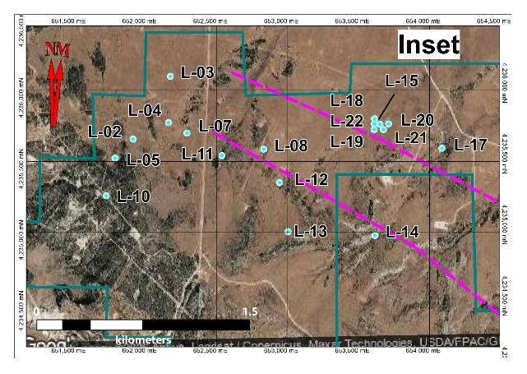
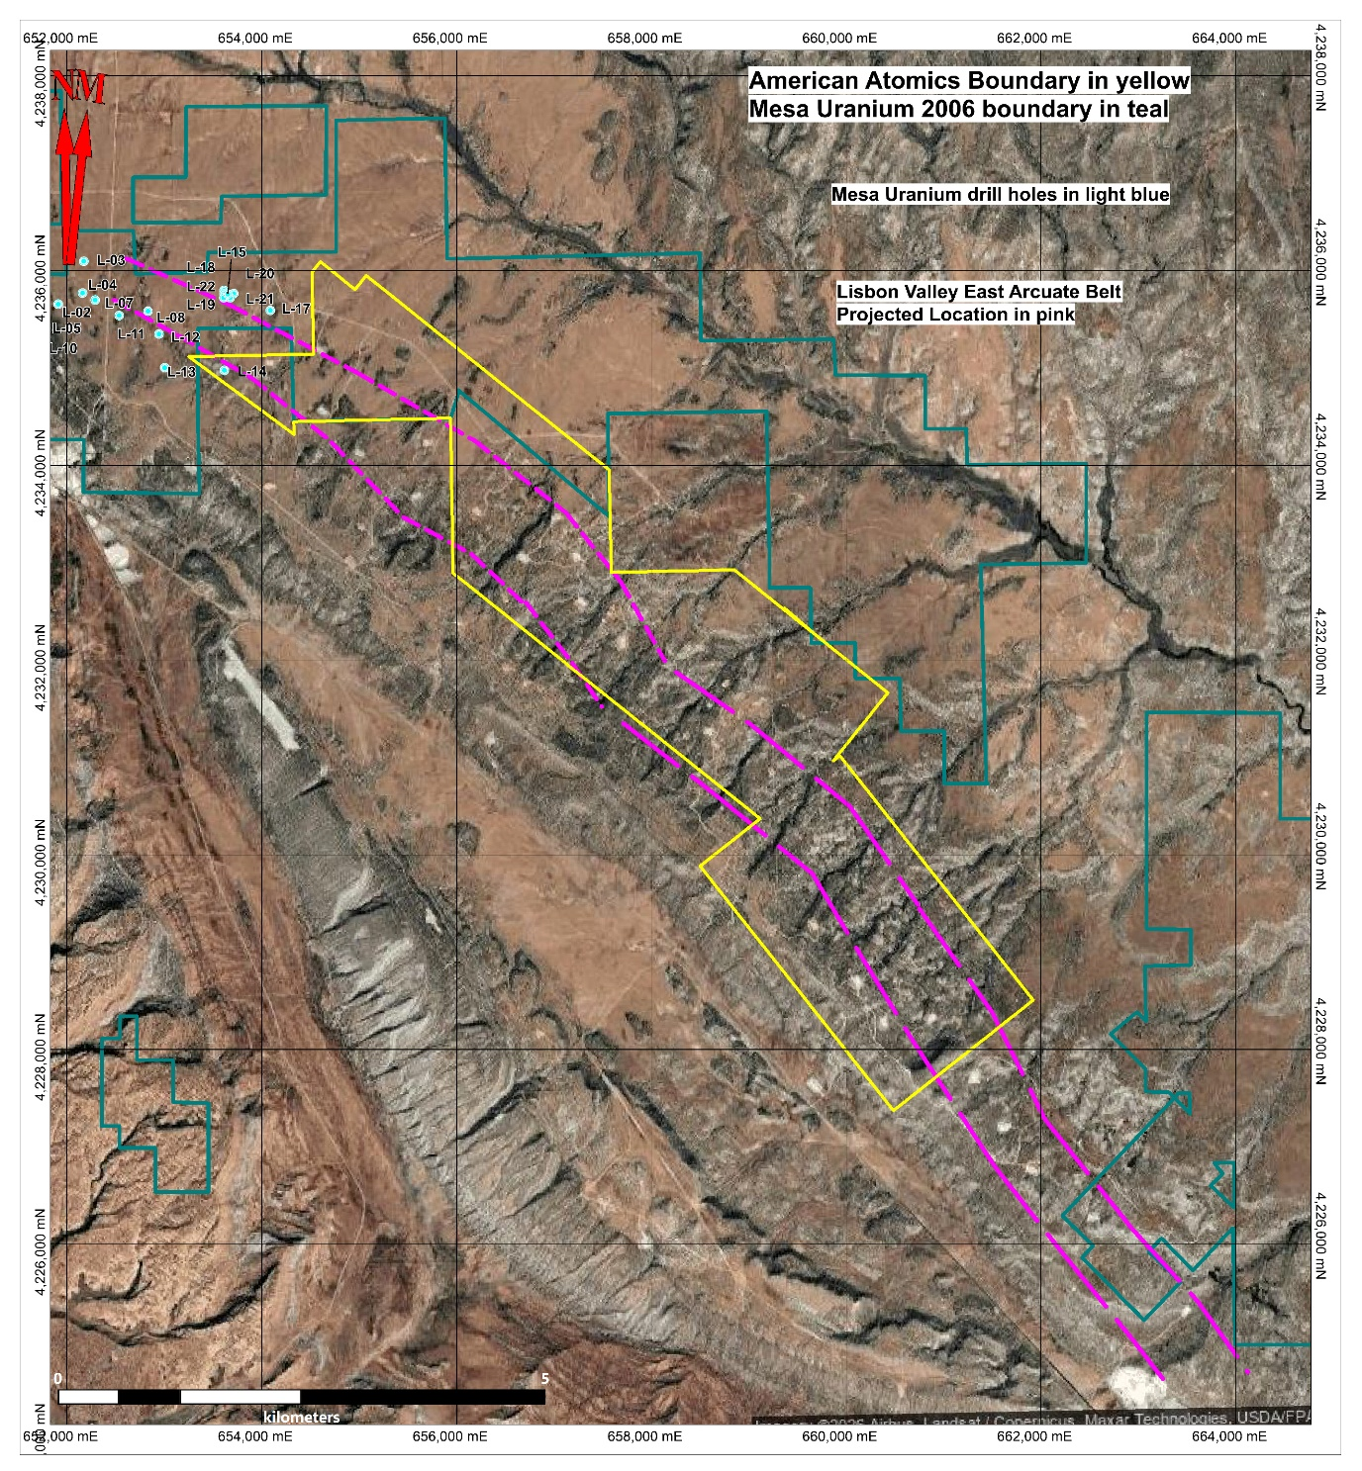

-14-

Universal Uranium 2006-2008
Universal Uranium held over 3,242 acres (1,313 hectares) during the 2005 to 2008 period, covering approximately 7.5 miles (12 kilometres) of strike along the subsequent suspected location of the Lisbon Valley East Arcuate Belt. They completed a series of 20 vertical holes totaling 51,257 feet (15,623 metres) during the period testing most of the strike length along their property (Figure 5). Details on drill hole lengths, geology and gamma ray probe intervals of the individual holes are contained in a private excel file compiled by former Universal Uranium director and project geologist Richard Dorman. The downhole probe percent eU₃O₈ intervals were subsequently released to the public in two news releases and shown in Table 3.

Figure 5. Universal Uranium 2006/2007 Drilling
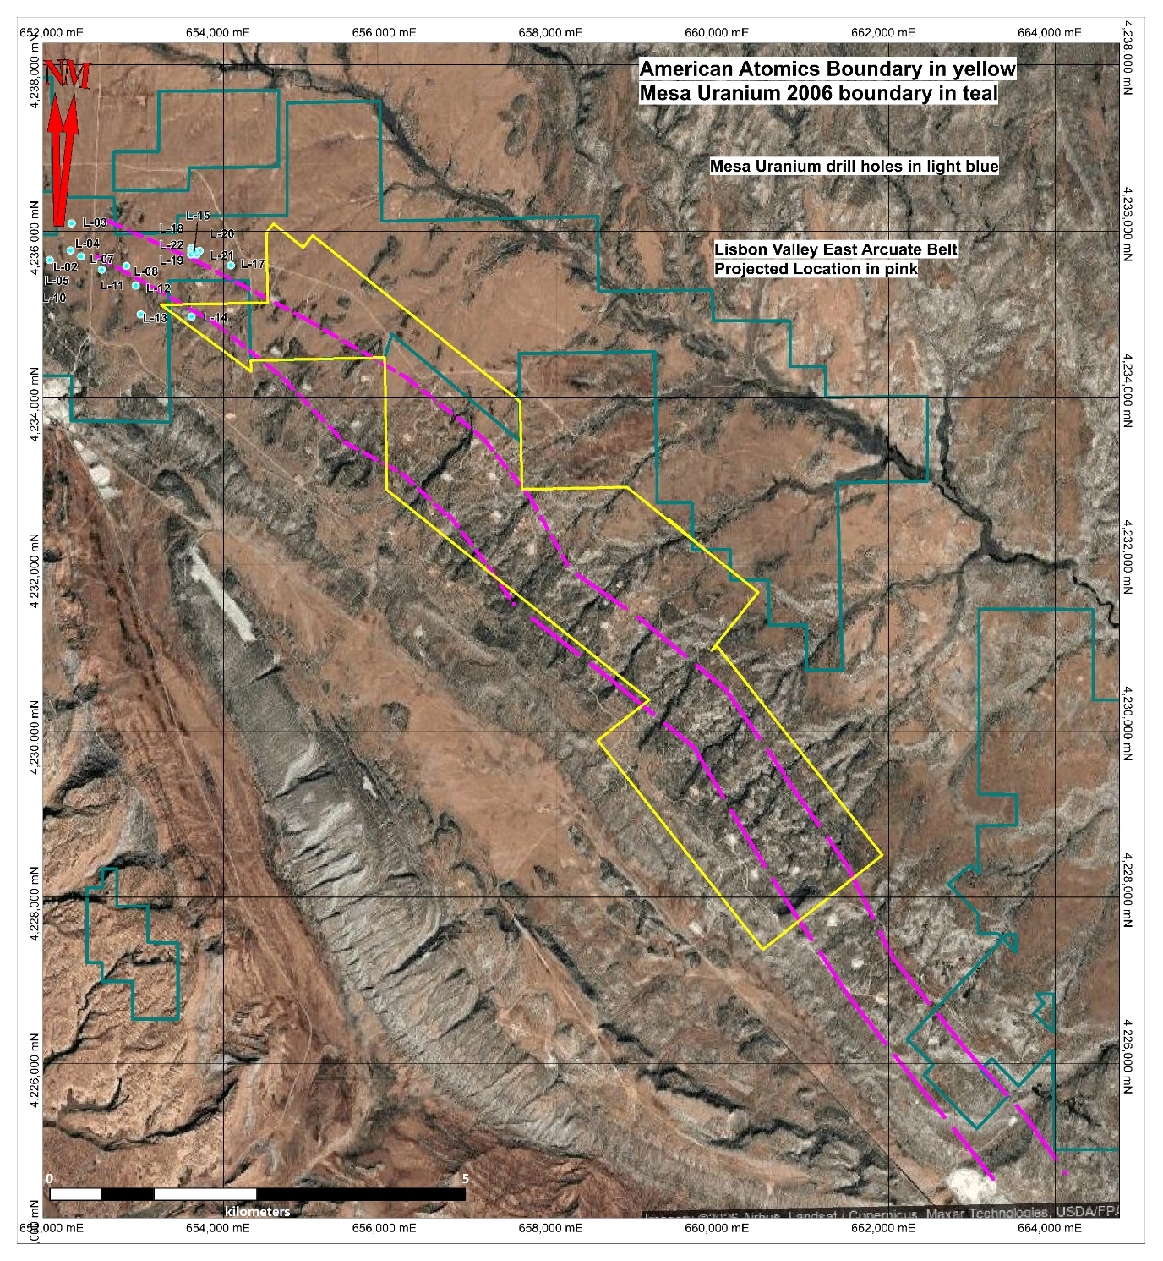
-15-

The Universal Uranium drilling is very significant as it further proved the Moss Back Member of the Chinle Formation is uraniferous on the downthrown side of the Lisbon Valley fault at depths of 2400 to 2600 feet (731.5 to 792.5 metres). Note that at least ten of the Universal holes were drilled to the southwest of the suspected Arcuate Belt. The uranium price drop in the 2008 2009 period effectively curtailed further exploration and Universal Uranium eventually let the claims lapse.

Table 3. Universal Uranium 2006 Lisbon Valley East Drill Results
Drill |  |  | feet | feet | feet | % |  | Drill |  |  | feet | feet | feet | %
hole | 83Z12E | 82Z12N | from | to | width | eU308 |  | hole | 83Z12E | 82Z12N | from | to | width | eU308
A 1 | 655303 | 4232882 | no Moss Back |  |  | -- |  | D 1 | 660242 | 4228675 | 2405 | 2425 | 20 | 0.043
A 2 | 655514 | 4232409 |  | 2558 |  | -- |  | D 1 | 660242 | 4228675 | 2405 | 2415 | 10 | 0.047
A5 | 655924 | 4233012 | 2480 | 2485 | 5 | 0.054 |  | D 1 | 660242 | 4228675 | 2420 | 2425 | 5 | 0.063
A5 | 655924 | 4233012 | 2490 | 2515 | 25 | 0.012 |  | D 5 | 661306 | 4228542 | 2405 | 2425 | 20 | 0.043
A5 | 655924 | 4233012 | 2530 | 2540 | 10 | 0.043 |  | D 5 | 661306 | 4228542 | 2405 | 2415 | 10 | 0.047
A 6 | 655815 | 4232596 | 2570 | 2600 | 30 | 0.017 |  | D 5 | 661306 | 4228542 | 2420 | 2425 | 5 | 0.063
A 7 | 655753 | 4232365 |  | 2626 |  | -- |  | E 5 | 661649 | 4227544 | no Moss Back |  |  | --
B3 | 658343 | 4230717 | 2315 | 2325 | 10 | 0.054 |  | E 6 | 661506 | 4227151 | no Moss Back |  |  | --
B3 | 658343 | 4230717 | 2555 | 2585 | 30 | 0.03 |  | 13 | 657476 | 4232356 | 2555 | 2560 | 5 | 0.013
B3 | 658343 | 4230717 | 2555 | 2560 | 5 | 0.05 |  | 14 | 657363 | 4232198 | 2518 | 2522 | 4 | 0.02
B3 | 658343 | 4230717 | 2580 | 2585 | 5 | 0.065 |  | 18 | 659495 | 4230182 | 2251 | 2254 | 3 | --
B5 | 657963 | 4231599 | 2435 | 2455 | 20 | 0.013 |  | 20 | 658473 | 4230839 | 2254 | 2380 |  | --
C4 | 658774 | 4230266 | 2580 | 2615 | 35 | 0.03 |  | 21 | 658497 | 4230671 | 2560 | 2570 | 10 | 0.025
C4 | 658774 | 4230266 | 2585 | 2590 | 5 | 0.064 |  | 27 | 658715 | 4230482 | 2054 | 2058 | 4 | --
C4 | 658774 | 4230266 | 2605 | 2610 | 5 | 0.06 |  | 27 | 658715 | 4230482 | 2314 | 2318 | 4 | --
 |  |  |  |  |  |  |  | 29 | 656771 | 4232600 | 2460 | 2472 | 12 | 0.01
 |  |  |  |  |  |  |  | 29 | 656771 | 4232600 | 2472 | 2487 | 15 | 0.02
 |  |  |  |  |  |  |  | 30 | 656637 | 4232414 |  | 2550 |  | --
The Universal Uranium drill results from the east side of the Lisbon Valley fault are sourced from Universal Uranium Ltd. news releases dated 2006-Aug-06 and 2007-Jan-25. “--“ means no significance gamma readings were obtained from the down hole probe. “No Moss Back” means the Moss Back Member was not present in the drill hole. The Moss Back was intersected in all other drill holes; if anomalous values were obtained then only the anomalous interval is shown in the table; if no anomalous values were obtained by the downhole probe then the base of Moss Back Member (feet to) is given in the table from data supplied by Richard Dorman, the project geologist at the time of the drilling.

Utah Oil and Gas Division Drillhole Database
Lisbon Valley lies within the Paradox Basin and as such has been explored for oil and gas in Pennsylvanian Hermosa Group, with 52 holes drilled within the Lisbon Valley East area, as shown on Figure 7 and listed on Table 4. These drill holes are important because they pass through the entire pre-Pennsylvanian stratigraphy on the way to the Hermosa Group, including the uraniferous Triassic Chinle Formation.

The Utah Division of Oil, Gas and Mining (UTO&G) has a relatively complete searchable online database that holds a series of downloadable files for each drill hole. These include the download file itself, consisting of the drill permit application which details amongst other
-16-

information, the estimated depth to the top of various stratigraphic formations and the planned total depth; well completion files which may or may not report actual depth to the top of the various formations calculated from the various downhole probe readouts (or logs); or an abandonment notice if the hole was not drilled. The log files include several individual paper printouts of various downhole probe surveys: for example, gamma ray, resistivity, sonic or neutron activation. Several of the logs displayed multiple surveys, with most of the gamma ray surveys actually found in the sonic or neutron activation log. Occasionally, no drill logs were filed with the drill hole and in other instances only gamma ray logs for the oil bearing interval were filed, meaning the interval through the Chinle Formation was not filed and the database is not complete.

Figure 6. Utah Oil and Gas Drilling
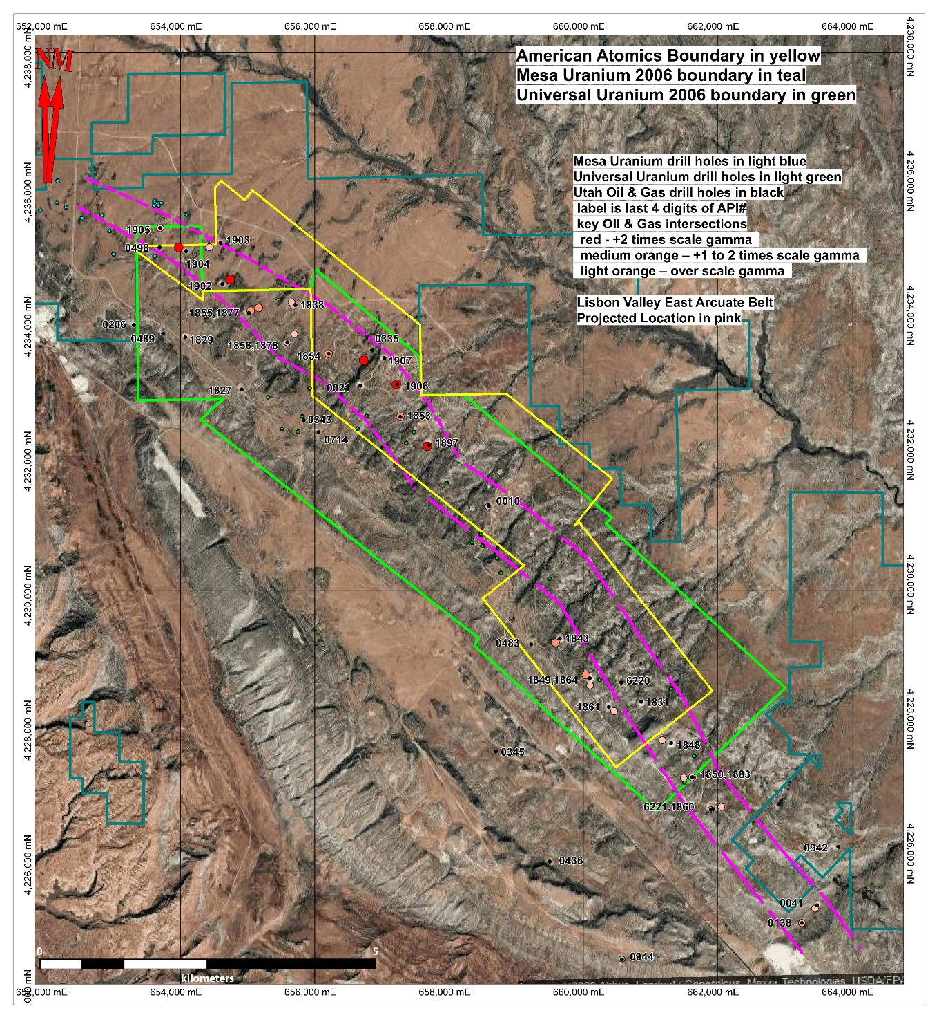
-17-

The following is taken from Lisbon Valley Utah Oil and Gas Drill Hole Database Review Henneberry (2024), which was subsequently revised in Henneberry (2025). (See Table 4). The down hole depths to the stratigraphic tops of the key formations: Wingate, Chinle, Cutler and Honaker Trail Formation (or Hermosa Group), the oil bearing sequence, were recorded. In a few instances, the stratigraphic top of the Chinle Formation - Moss Back Member was recorded. The estimated down hole depths to the tops of the various formation tops are taken from the Application to Drill document and are shown in Table 4 as "Est xxxx". In most instances actual depth of the formation tops can be found in the log completion forms; these are recorded without the "Est". In several instances, only the actual tops to the Cutler and Honaker Trail (or Hermosa Group) were recorded, neglecting the younger formations; in those instances the younger formations were left as estimated.

The downloaded resistivity, sonic or neutron log was reviewed, focusing on the target depth 2550 feet to 2850 feet, guided in part by the stratigraphic tops. The gamma ray probe was calibrated to the American Petroleum Institute (API) standards, where 16.5 API units corresponds to a concentration of radioactive elements equal to 1 microgram of radium per ton. The vast majority of the gamma ray logs in the drill holes reviewed had a lower and upper scale limit of 0 to 150 API units, 0 to 160 API units or 0 to 200 API units in the paper printout. The results were tabulated with the maximum reading within an anomalous interval recorded as well as the upper and lower down hole distance in feet for each anomalous interval. (Table 4). All drill holes with a maximum API reading over scale were considered anomalous, while readings twice over scale were considered very anomalous. There were four instances where the needle formed a solid black line indicating an extremely anomalous interval. These readings are recorded as “1000” in Table 4. Figure 7 shows a screen shot of a number of the key gamma ray log intervals.

The abandoned drill collars sited were removed and the remaining drill collars were plotted and labelled on Figure 6. The plan location of the intersection for each over scale gamma reading was also plotted to the legend below. Several of the holes were drilled directionally, not vertically, so the down hole survey was consulted and the actual plan location was calculated for the plot (Table 4a.). Intersection Legend:
- red - +2 times scale gamma
- medium orange – +1 to 2 times scale gamma
- light orange – over scale gamma

The projected location of the suspected arcuate belt on the downthrown side of the Lisbon Valley fault was then sketched on to the plan map guided by the oil and gas drill hole gamma ray anomalies. The DBI 1-217 claims were then staked based on the projected location of the arcuate belt.

-18-
Table 4. Utah Oil and Gas Drill Hole Database Chinle Formation Gamma Ray Results

-19-
Table 4a. Utah Oil and Gas Drill Hole Key Intersection Northing and Easting Coordinates

-20-

Figure 7. Anomalous Gamma Ray from Select Lisbon Valley Utah Oil and Gas Drill Holes
API Scale 1-150 4303731902 | API Scale 1-150 4303731903 | API Scale 1-150 4303731904 | API Scale 1-150 4303731907 | API Scale 1-150  4303731906
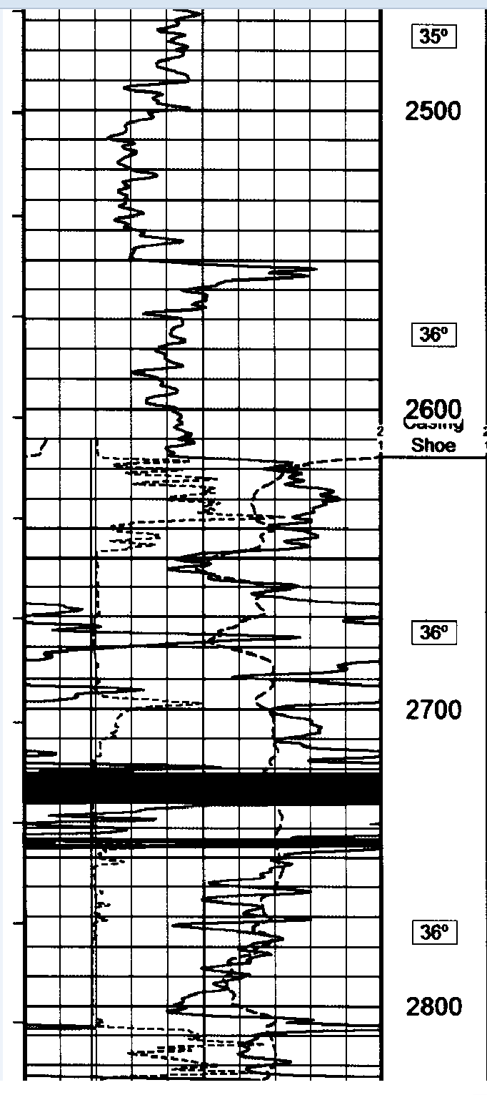 | 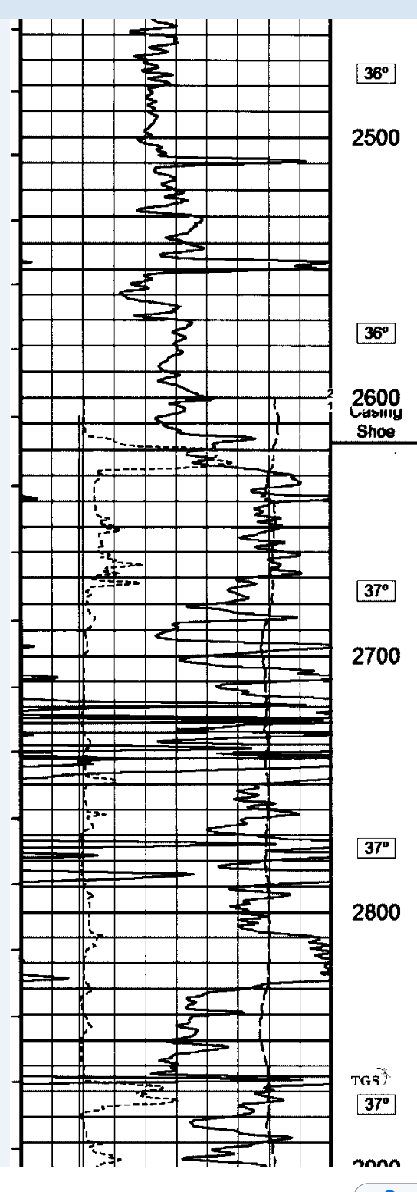 | 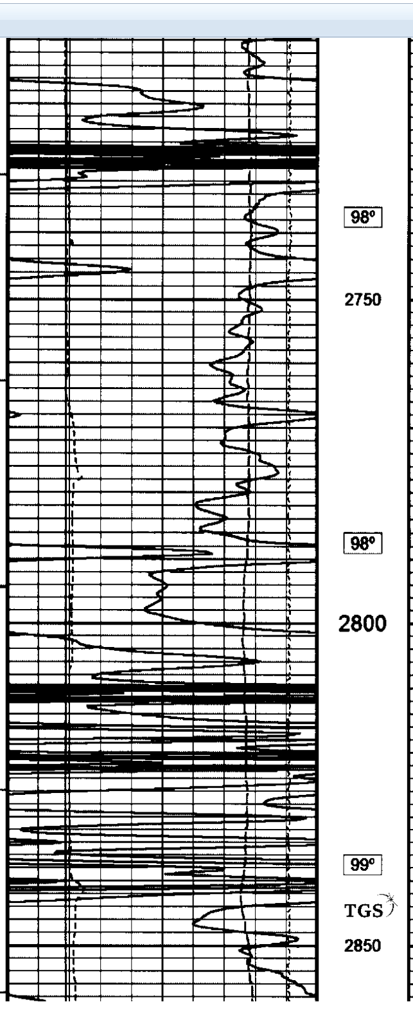 | 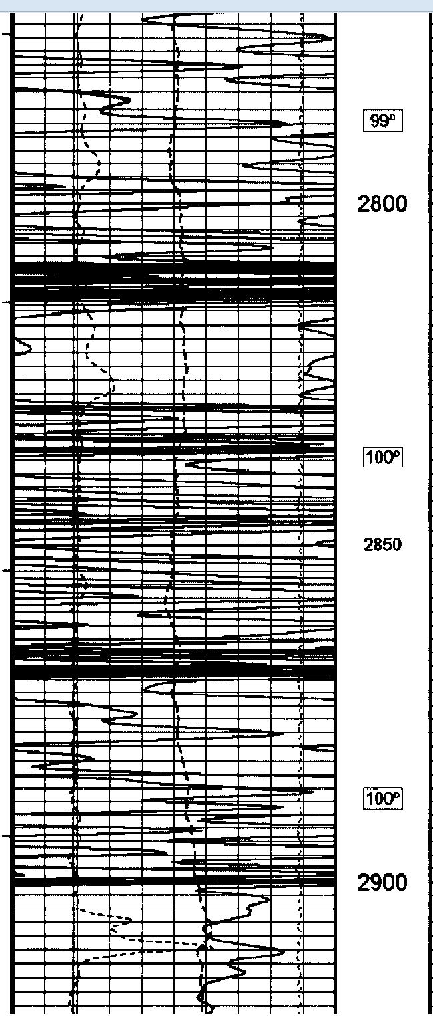 | 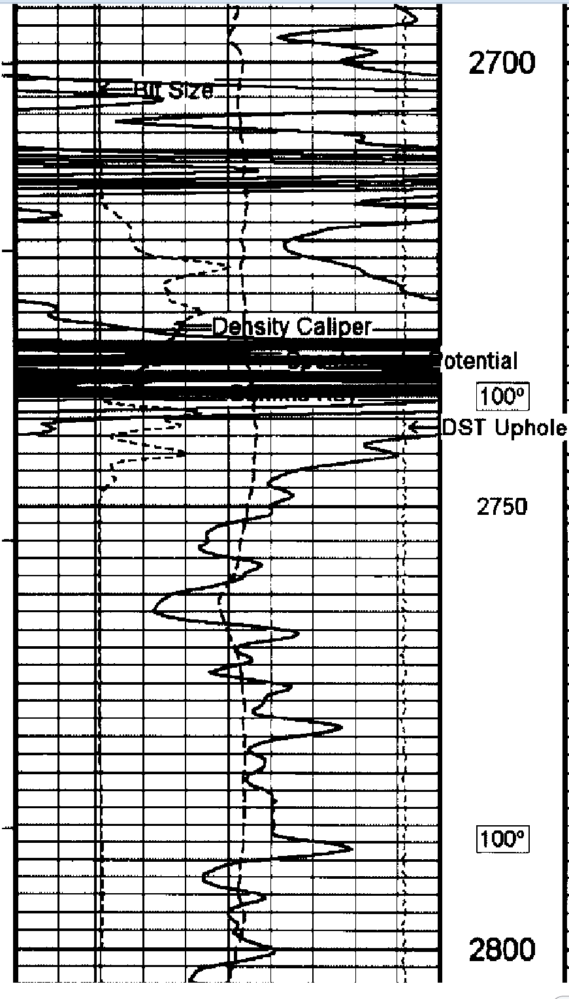

GEOLOGICAL SETTING AND MINERALIZATION

The Lisbon Valley East project lies in Colorado Plateau, a major physiographic province covering parts of the Four Corner states: Utah, Colorado, New Mexico and Arizona. The following discussion on the geologic setting of the Colorado Plateau is taken from Hall et al (2023).

The Colorado Plateau physiographic province (the Plateau) in the states of Utah, Colorado, Arizona, and New Mexico hosts the largest uranium province in the USA and one of the largest in the world. The Plateau is a roughly 130,000 square mile (336,700 square kilometre) region of relatively undeformed, predominately flat-lying, mostly sedimentary rocks that were uplifted in the Cenozoic. Most uranium deposits are hosted in the Triassic Chinle and Jurassic Morrison Formations that formed in mostly arid environments. These deposits are exposed today along cliffs and drainages that transect the Plateau and have been mined for vanadium since 1909 and for uranium since the 1948 Atomic Energy Commission Act.

During the Paleozoic and Mesozoic, marine and continental sediments were deposited throughout the Colorado Plateau. Between ~ 315 and 150 Ma, the ancestral Rocky Mountains separated the Plateau from the rest of the North American craton to the east. The associated Uncompahgre Uplift intermittently provided clastic sediment to the Plateau from the east, although the dominant sediment transport direction was from the southeast. In the Triassic, gradual subsidence of the Plateau began and continued throughout the Mesozoic. In the Late Jurassic, the Nevadan orogeny impacted the region, forming mountains in the west and shifting the dominant river transport direction from southeast-northwest to southwest-northeast.

-21-

Figure 8. Stratigraphic Column of the Colorado Plateau (from Hall et al, 2023)
Generalized stratigraphy, intervals of volcanic ash and major tectonic episodes of that part of the geologic section that hosts uranium deposits in the Colorado Plateau. Strata that are important host rocks for uranium deposits are designated with an upper case “U”, less significant uranium host rock is designated with a lower case “u”.

-22-

During the Cenozoic, between ~ 80 and 40 Ma, the region was uplifted an estimated 1.6 kilometres. Far-field tectonism during the Laramide orogeny (~ 80 to 40 Ma) folded and faulted rock throughout the Plateau.

Geologic History
During the Pennsylvanian, fluctuating sea level created an environment in which clastic sediments shed from the Uncompahgre Uplift in the eastern part of the Plateau were interbedded with both marine and non-marine carbonates in the central and western part of the Plateau. Thick interbedded evaporites and black shales of the Paradox Formation of the Hermosa Group were deposited in the northeastern part of the Plateau during the Middle Pennsylvanian. These salts began to flow in the Permian and this flow continues today creating the salt anticlines that still dominate the landscape.

During the early Permian (Wolfcampian), the sea retreated westward, the environment was arid, and sediment was shed from the Ancestral Rockies in a northeast to southwest direction forming the red beds of the Cutler Formation. Some uranium deposits are hosted in the Cutler Formation. The Kaibab Formation was deposited during a widespread marine transgression in the latest early Permian (Leonardian). A widespread regional unconformity at the top of the Kaibab Formation caused by lowering global sea level separates it from the overlying Triassic Moenkopi Formation.

The Moenkopi Formation in the lowermost Triassic formed in a low-energy fluvial setting, and is a widespread red bed unit, although parts are bleached or altered from original red to a greyish color. A regional unconformity, possibly related to migration of the Cordilleran arc eastward, separates the top of the Moenkopi from the overlying Chinle Formation, exposing Permian, Pennsylvanian, and Precambrian strata throughout the Plateau.

During the Early Triassic, river flow shifted to a dominant transport direction of south-southeast to northwest, which persisted throughout the Late Jurassic. Large river systems that developed during this time (~ 240 Ma) may have originated from the Ouachita or distal southern Appalachians and deposited clastic sediments throughout present day Colorado, Arizona, and New Mexico, while marine rocks formed in northwestern Utah. Erosional channels formed by this river system deposited conglomerates of the Shinarump Member of the Chinle Formation into erosional scours in the underlying Moenkopi Formation. A volcanic arc developed along the Cordilleran margin west of the Plateau in the early Triassic, which provided volcanic detritus and intermediate to felsic ash to the Triassic Chinle Formation.

The Shinarump and Moss Back Members of the Chinle Formation contain most of the Triassic-hosted uranium mineralization in the Plateau. Small uneconomic deposits are also identified in the Monitor Butte and Petrified Forest Members of the Chinle Formation and sandstones in the underlying Moenkopi Formation. The climate during deposition of the Chinle was seasonally arid with periods of significant (monsoonal) precipitation evolving to a more arid climate during deposition of the upper part. Direct evidence of volcanism (lithic volcanic clasts and ash shards) and indirect evidence (bentonitic clay and analcime arguably from altered ash) indicates volcanics were deposited in the lower part of the Chinle from caldera eruptions and eroding Triassic plutons west of the basin. However, the extent and volume of ash is not well understood because ash beds are not typically preserved in the fluvial lithofacies of the Chinle.
-23-

The Jurassic Glen Canyon Group (Wingate sandstone, Moenave Formation, Kayenta Formation, and Navajo sandstone) unconformably overlies the Chinle Formation. This unconformity may be related to the development of a strongly arid environment causing a lack of sediment accumulation that persisted through the Middle Jurassic.

Figure 9. Geology of the Lisbon Valley Area (from Doelling, 2004)
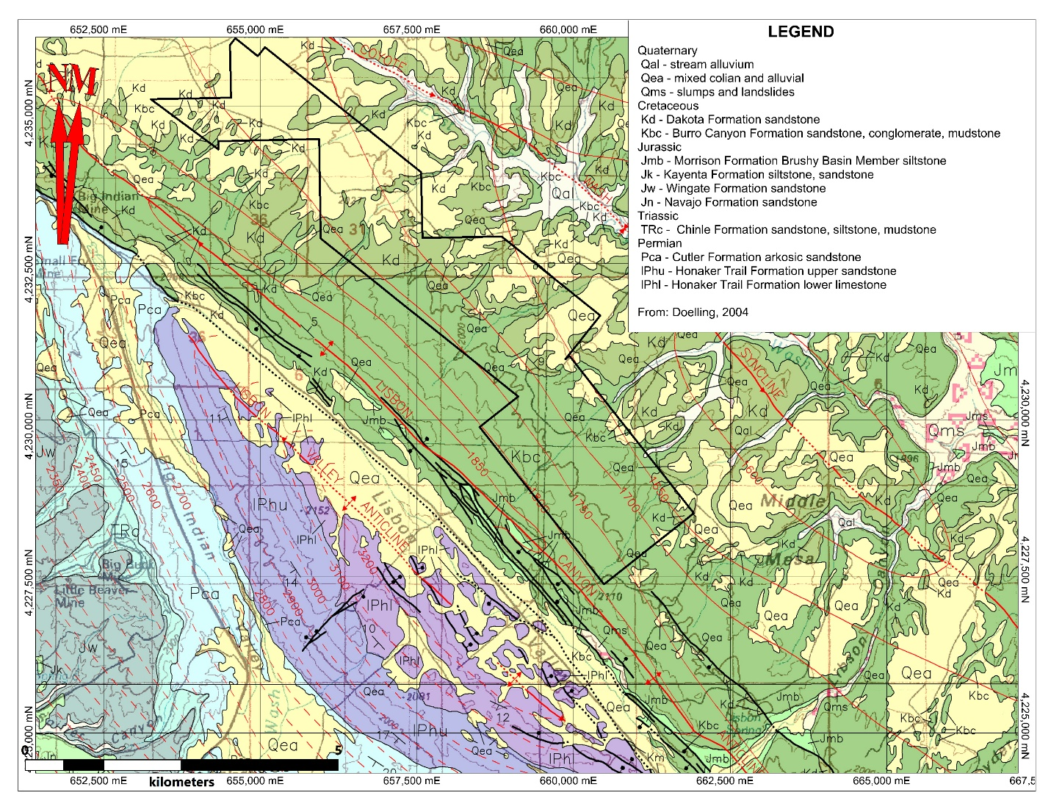

The Jurassic Glen Canyon Group (Wingate Sandstone, Moenave Formation, Kayenta Formation, and Navajo Sandstone) unconformably overlies the Chinle Formation. This unconformity may be related to the development of a strongly arid environment causing a lack of sediment accumulation that persisted through the Middle Jurassic.

At the base of the Glen Canyon Group, the Wingate sandstone marks the beginning of widespread dune fields, and the formation of a large inland delta. Sediments were transported by water originating in the southeast as it moved northwest toward present day Utah and evaporated. The overlying Kayenta Formation and Navajo sandstone record expansion of the arid conditions. A volcanic arc formed in Arizona during the Early Jurassic, and ash interfingers with the Navajo sandstone in Arizona. Minor uranium mineralization is hosted in the Kayenta Formation and Navajo sandstone. A widespread regional unconformity separates the top of the

-24-

Glen Canyon Group from the overlying Middle Jurassic San Rafael Group. This unconformity is attributed to exhumation caused by thrusting of the Early Triassic Cordilleran magmatic arc west of the Plateau.

The San Rafael Group formed in arid conditions during inundation by the epicontinental Sundance Sea from the northwest into present day Utah. The units within the San Rafael Group are variable continental siliciclastic units formed in evaporative conditions at the edge of the Sea, dune fields in the central part of the Plateau, and continental red beds elsewhere. Sediment was transported from the south. Large sand seas developed once again at the top of the San Rafael Group. The contact between the San Rafael Group and overlying Upper Jurassic Morrison Formation is marked by a regional unconformity that is likely related to development of the Cordilleran magmatic arc to the south and west that shifted the direction of dominant sediment transport to southwest -northeast.

The environment during deposition of the Upper Jurassic Morrison Formation continued to be arid, and widespread dune fields that were established during deposition of the underlying Entrada sandstone persisted into the lower part of the Morrison (Salt Wash Member). Sand seas diminished throughout the Late Jurassic, and the upper part of the Morrison (Brushy Basin Member) formed from large river systems that originated in mountains to the west and south. These rivers fed lakes in the central part of present-day Utah and saline lakes in the southwestern parts of present-day Colorado and New Mexico. Volcanic ash beds are found in the Carmel and Temple Cap Formations of the San Rafael Group and Tidwell and Brushy Basin Members of the Morrison Formation. Ash is interpreted to have been deposited in the saline lakes that formed in the southwestern part of the basin. The ash was deposited in two pulses, from roughly 171 to 166 Ma and roughly 155 to 148 Ma and is similar in age and composition to Jurassic calc-alkaline arc volcanism that developed west of the Plateau in present day California and Nevada. Mineralization is hosted by the Salt Wash Member throughout the Plateau and by the Westwater Canyon, Brushy Basin, and Jackpile Members in the southeastern part of the Plateau.

A widespread regional unconformity at the Jurassic-Cretaceous boundary is thought to be caused by thermal uplift emanating from the Cordilleran magmatic arc that was active south and west of the Plateau. In response to thrusting west of the Plateau, a Cretaceous foreland basin developed in the Plateau that was filled with marine sediments (Mancos Shale) and associated beach and coastal plain deposits (Dakota, Cedar Mountain, and Burro Canyon Formations) deposited in the Western Interior Seaway.

The Colorado Plateau was uplifted about 1 mile (1.6 km) from about 66 to 36 Ma as a relatively undeformed block. During the Laramide orogeny, far-field tectonics folded and fractured Mesozoic sediments and dissected the Plateau into smaller intracratonic basins, laccoliths intruded the region, and in the southern part of the Plateau, the Zuni Uplift formed.

Salt Anticlines
A brief discussion on salt anticlines is required as they are a key aspect in the development of the deposition of the Chinle Formation and hence the penecordant uranium mineralization. The following summary is taken and modified from the abstract of Doelling (1983).
-25-

The Paradox Basin, formed in Pennsylvanian time along a dominant set of northwest-trending faults or flexures that cut the older basement rocks, is about 200 mi (320 km) long and 80 mi (128 km) wide at its widest point. As the basin subsided, the Uncompahgre highland was elevated to the northeast along the northeastern-most of these faults. All of the paralleling faults to the southwest were downthrown on their northeast sides, each lowering the basement as steps to form the basin. The degree of Paradox Basin collapse therefore gradually decreases southwestward. Salt was deposited as the basin was lowered cyclically, with the thickest deposition occurring in the deeper northeastern part.

Deformation of the salt beds started soon after they were deposited with continued movement on the basement faults or flexures likely initiating salt flowage. The greater deformation occurred in the deeper part of the basin. The salt was thickened along the immediate downthrown sides of the faults, forming elongate northwest-trending salt cores. The entire area continued to subside, and succeeding formations were deposited over the salt deposits through Early Tertiary time. Through Middle Triassic time, salt was squeezed from intervening areas toward the developing salt cores, and the overlying sediments were periodically pushed upward or breached, with individual formations elevated to form anticlines.

These salt anticlines are therefore aligned in a northwest-southeast orientation, developing four aligned groups of anticlines spanning a strike length of 65 to 100 miles (104 to 160 kilometres). Anticlinal development commenced prior to the Triassic, resulting in a series of northwest trending hills (anticlines) and valleys which hosted Triassic streams and rivers. The sands and gravels from these streams and rivers were subsequently deposited as the lower Chinle Moss Back and Shinarump Members, either directly on the Cutler Formation or on the intervening Moenkopi Formation.

Local Geology
The formations key to the Lisbon Valley East project area were described in detail by Lahusen (1977), consisting of the Permian Cutler Formation and Triassic Moenkopi Formation and Chinle Formation. Larry Lahusen is an experienced Colorado Plateau uranium geologist responsible for two discoveries including the Velvet Mine in the Lisbon Valley area. In 1977, he completed a report “Concepts of Uranium Deposition Big Indian Ore Belt” which appears to be a combination of his observations and thoughts on the Lisbon Valley area based on his years of experience and largely guided by the work of H.B. Wood (1968) and his fellow geologists of the US Atomic Energy Commission.

The Cutler Formation in Lisbon Valley is a redbed sequence of alternating sandstone and siltstone ranging from 900 feet to 1,800 feet in thickness. The Cutler Formation is a complex accumulation of continental sediments made up of alternating beds or lenses of light pink, orange, lavendar and buff arkosic sandstone, mudstone and calcareous siltstone. The fluviatile sandstone beds are well-sorted, fine-to-medium grained, composed of quartz, feldspar and biotite with calcite and clay being the main cementing material.

-26-

The Moenkopi Formation has been eroded back off the Lisbon Valley anticline where it has been penetrated in oil and gas test wells drilled low on the flank of the anticline. Where exposed in southeastern Utah, the Moenkopi consists of interbedded dark-red to chocolate-brown laminated, micaceous, ripple-marked shales and siltstones, containing a few thin, well-sorted, fine-grained sandstone beds. The Moenkopi is widespread throughout the Paradox basin and is normally unconformably overlain by the Chinle Formation.

The Chinle is separated into only two major parts: (1) the upper (red­ beds) part and (2) lower or basal sandstone and conglomerate part, herein referred to as the Moss Back Member. The upper (red-bed) part of the Chinle Formation consists of lacustrine sediments ranging from about 275 feet to 400 feet thickness, composed of variegated reddish-brown, purple and lavendar horizontally bedded or structureless thin interbedded siltstone and shale with lesser amounts of sand­stone and limestone.

The lower part of the Chinle is the Moss Back Member which ranges from 10 to 80 feet in thickness and was deposited in the Lisbon Valley area on the irregular erosional surface of the Cutler. The Moss Back Member, the main uranium­ bearing host in the Big Indian district, is predominantly a fluviatile sandstone that can be separated into an upper and lower facies.

The upper facies is typically a medium-gray-buff and yellowish-gray fine-to-medium grained, well-sorted sandstone with interbedded conglomeratic sandstone lenses and green shale or claystone partings. The sandstone is generally composed of sub-rounded clear quartz with lesser amounts of chert, feldspar and limestone grains. Regionally the upper Moss Back sandstone facies is a relatively massive blanket­like deposit of fairly even thickness, generally 30 to 50 feet, that covers all of southeast Utah and adjacent southwest Colorado. The upper Moss Back facies is not the uranium-bearing facies in the Big Indian district.

The lower Moss Back sandstone facies in the Lisbon Valley area was deposited directly on the erosional surface of the Cutler and separated from the upper Moss Back facies by a thin shale unit. The lower facies is typically a light­ gray fine-to-medium grained arkosic sandstone composed of quartz, feldspar and jasper with lesser amounts of chert and abundant interstitial green shale, claystone and carbonaceous material. In contrast to the massive bedded blanket-like characteristics of the upper Moss Back facies, the lower sandstone facies is not widespread, being confined to channel deposits or scour filled areas ranging from 5 to 30 feet thick. The lower sandstone facies is the major uranium host in the Big Indian Wash district.

Favorable lithology of the lower facies is a gray, poorly-sorted, fine-to-coarse grained, highly calcareous, arkosic quartzose sandstone with abundant interbedded gray-green mudstone lenses and galls. The main ore-bearing areas are normally semi-permeable, fine-grained sandy lenses that contain jasper, smoky quartz, fresh-looking feldspar, pyrite, abundant carbon as particulate material and reddish-brown or pink calcite, colored by secondary hematite.

-27-

Lahusen (1977) also offered his observations on structure in the Lisbon Valley area, again guided by Wood (1968). In Pennsylvanian time, a deep asymmetrical basin, the Paradox basin, developed southwest of the northwest trending Uncompahgre Highland. During Permian time plastic flow of the evaporites that accumulated in the deepest parts of the basin began to rise, forming a series of parallel salt anticlines that trend generally northwest parallel to the front of the Uncompahgre uplift. The deepest part of the Paradox basin occurs close to the Uncompahgre front and is separated from the shallower parts of the basin to the southwest by a series of faults or warps that coincide with the southwest flanks of some of the larger salt anticlines (Paradox, Gypsum, Lisbon and Moab Valley). Uplift and maximum growth of the ancestral salt anticlines occurred during Late Permian time and continued into Late Triassic time.

Table 5. Lahusen (1977) Table 1. Chinle Formation Production from Lisbon Valley District Mines 1948-1977
North Lisbon |  |  |  |  | South Lisbon
Mine | Tons | % U3O8 | ibs U3O8 |  | Mine | Tons | % U3O8 | ibs U3O8
Lisbon Mine | 2,045,455 | 0.22 | 9,000,000 |  | Continental | 70,000 | 0.43 | 602,000
North Alice | 600,000 | 0.25 | 3,000,000 |  | Divide | 18,000 | 0.41 | 147,000
Far West | 760,000 | 0.35 | 5,320,000 |  | Velvet | 39,000 | 0.41 | 320,200
Radon | 560,000 | 0.65 | 7,280,000 |  | Woods | 300,000 | 0.25 | 1,500,000
Cord | 400,000 | 0.55 | 4,400,000 |  | South Total | 427,000 | 0.301 | 2,569,200
Bowlings, et al | 150,000 | 0.25 | 750,000
Columbia | 360,000 | 0.36 | 2,600,000 |  | Total | 8,928,455 | 0.341 | 60,974,200
San Juan | 180,000 | 0.20 | 720,000
La Sal (Small Fry) | 495,000 | 0.14 | 1,320,000
Ike-Nixon | 170,000 | 0.85 | 2,890,000
Mi Vida | 1,200,000 | 0.35 | 8,400,000
Big Buck | 350,000 | 0.25 | 1,750,000
Louise-Standard | 1,050,000 | 0.45 | 9,450,000
Stinko | 25,000 | 0.25 | 125,000
Little Beaver | 80,000 | 0.35 | 560,000
Expectation (Texwood) | 40,000 | 0.35 | 280,000
Skunkovitch | 36,000 | 0.35 | 560,000
North Total | 8,501,455 | 0.344 | 58,405,000
The Chinle Formation production from various Lisbon Valley District mines between 1948 and 1977 is taken from Lahusen (1977). He noted the following with respect to the yearly production figures: The above production records for the Big Indian Ore Belt are accurate during the district's boom period, 1952-1965. Production figures for the newer and later reworked mines were obtained from unpublished data and in some cases represent estimates only.

The northwest trending Dolores, Lisbon and Moab Valley salt anticlines formed the axis of the deepest part of the Paradox basin. These ancestral highs formed a ridge-line that was exposed to extensive erosion, whereby hundreds of feet of Cutler and Moenkopi sediments were denuded from the crest of the ancestral arch, prior to the deposition of fluviatile sediments over the structure by Moss Back streams. The top of the Cutler throughout the Lisbon Valley area represents a notable unconformity. Erosional thinning of the Cutler over the Lisbon Valley anticline exemplifies the structure's Permian ancestry. The overlying Moenkopi Formation, normally widespread throughout the Paradox basin, was completely removed, resulting in the Cutler-Chinle nonconformity.
-28-

The Cutler-Chinle nonconformity has an angle of discordance between the beds of the Cutler and Chinle Formations, ranging from 2° at the northwest end of the anticline to about 6° near the central part of the anticline, and to approximately 3° to 4° at the southern end of the structure. The paleo­topography of the nonconformity has a variable undulating surface ranging from less than 5 feet of relief to a deeply scoured surface of over 30 feet of relief.

A second period of major uplift and collapse of the ancestral Lisbon Valley anticline occurred during the Laramide Orogeny. The younger Tertiary anticline forms the present physiographic structure, the two anticlines having separate but nearly parallel axes.

Mineralization
Lahusen (1977) offered his thoughts and observations on the uranium mineralization current to the date of his report, relying heavily on Wood (1968). The Big Indian Wash district is a 15-mile-long by half-mile-wide ore belt consisting of numerous intermittent uranium ore bodies ranging in size from 200,000 pounds U₃O₈ to 20,000,000 pounds U₃O₈. Except for the occurrence of a few secondary uranium deposits in the underlying Cutler sandstone, the majority of the uranium production from the Big Indian ore belt occurred in the Moss Back Member of the Chinle Formation. The ore belt can be separated into two major areas of production: the northern and southern parts.

The most productive is a seven-mile stretch covering the northern part of the ore belt which
occupies the southwest flank of the northwest nose or plunging edge of the ancestral Lisbon Valley anticline. Production from this area has come from a few coalesced deposits ranging from 16,000,000 to 20,000,000 pounds U₃O₈, and a number of separate ore deposits ranging from 2,000,000 to 5,000,000 pounds U₃O₈. Production from this area from 1948 to 1977 is in excess of 59,000,000 pounds of U₃O₈ . The average size of the ten largest deposits in this area is approximately 6,000,000 pounds of U₃O₈ at an average grade of 0.35% U₃O₈ with an average thickness of six (6) feet.

The second area of production in the Big Indian ore belt is a four-mile stretch of smaller scattered ore deposits that covers the southern quarter of the Lisbon Valley anticline. The ore deposits in this area are considerably smaller, ranging from 350,000 to 2,000,000 pounds of U₃O₈. Total past production in this area amounts to approximately 3,000,000 pounds of U₃O₈.

A five-mile stretch in the central to south-central part of the Big Indian ore belt has had no production. Published geological reports suggest the ore belt has been removed by erosion in this area, evidence for which is indicated by anomalous radioactivity in the alluvium of Big Indian Valley between the Standard and Serviceberry Mines.

Table 6. Lahusen (1977) Figure 7 – Comparisons of Tons U₃O₈ discovered per Linear Mile
District | State | Miles Length | Tons U₃O₈ per Mile
Southern San Juan | New Mexico | 90 | 2,559
Lisbon Valley | Utah | 13 | 2,153
Uravan | Colorado-Utah | 65 | 560
Powder River Basin | Wyoming | 67 | 438
Coastal Plain | Texas | 92 | 255

-29-

One of the unique features of the Big Indian ore belt is its clustering of elongate, highly concentrated or enriched uranium deposits over such a small surface area. Figure 7 is a comparison of tons of discovered U₃O₈ per linear mile in some belts. For further reference on the total production and on individual mine production and grade, see the attached Table #1. The Department of Energy has established the total uranium production from the Big Indian District from 1948 to 1977 at 9,490,000 tons or 62,958,000 pounds U₃O₈, averaging approximately 0.33% U₃O₈. This includes uranium production from the Cutler, which is why these figures do not exactly match with Table #1.

Although the Big Indian Wash district has been producing off and on since 1948, the major production took place from 1952 to 1965, which depleted most of the major ore deposits. Uranium production from the district today comes from a few scattered new ore deposits and the reworking of a few existing mines. The bulk of the uranium production from the Big Indian district today comes from the Lisbon Mine which was discovered by Rio Algom in 1966. The discovery of this ore body established the existence of uranium ore on the northeast down-thrown side of the Lisbon Valley fault that has more than 2,200 feet of displacement. The Lisbon Valley fault is a post ore structure which offset the Moss Back ore bed, the Lisbon deposit being the extension of the North Alice ore trend that was previously mined up to the fault (Fig. 1). The Lisbon mine has produced from 1970 at the rate of approximately 1,000 tons per day with a mine grade ranging from 0.20% to 0.25% U₃O₈. It is estimated that at least 9,000,000 pounds has presently been produced from the deposit with an additional 10,000,000 pounds U₃O₈in reserves.

Other recent discoveries and presently producing mines in the ore belt are the Woods Mine discovered by Atlas Minerals in 1973 and the Small Fry Mine discovered by Ranchers Exploration in 1974. Production and reserves from each of these mines is estimated to range from 1,000,000 to 1,500,000 pounds U₃O₈. Both mines are presently producing; however, close to being exhausted.

Additional production in the Big Indian district is from existing mines that are being reworked.
Atlas Minerals is presently operating at the Far West Mine and the Standard Mine, a Cutler uranium occurrence. New Mexico-Arizona Land Company is presently in operation at the North Alice Mine. Production from these mines ranges from approximately 250 to 4,000 tons per day at grades ranging from 0.10% to 0.20% U₃O₈. The ore production per year over the last two years is estimated not to have exceeded 2,500,000 pounds U₃O₈ per year as compared to the peak ore production years of 1958-1959 of over 6,300,000 pounds U₃O₈ per year.

The work largely by Wood (1968) and Lahusen (1977) has shown the southwest side of the Lisbon Valley fault hosted some very significant uranium ore bodies, in the order of 1 to 20 million pounds of U₃O₈, with an average size of 6 million pounds and an average grade of 0.34% U₃O₈. (Figure 10) As is common in mining camps, multiple properties or mines shared parts of the same orebody, explaining why none of the mines in Table 5 show 20, 000,000 lbs U₃O₈ in production.

Their work strongly suggests the presence of a second arcuate belt on the down thrown side of the Lisbon Valley fault based on the Triassic geology of the anticlinal salt dome structures through the Paradox Basin area of the Colorado Plateau; Lahusen recognized “…the Lisbon deposit being the extension of the North Alice ore trend that was previously mined up to the fault…” the Lisbon Valley fault cut a continuous ore body on the nose of the anticline, dropping the downthrown side +2200 feet. The issue has always been tracing the suspected arcuate belt south from the Rio Algom Lisbon Valley Mine.
-30-

Figure 10. Lisbon Valley Mineralization
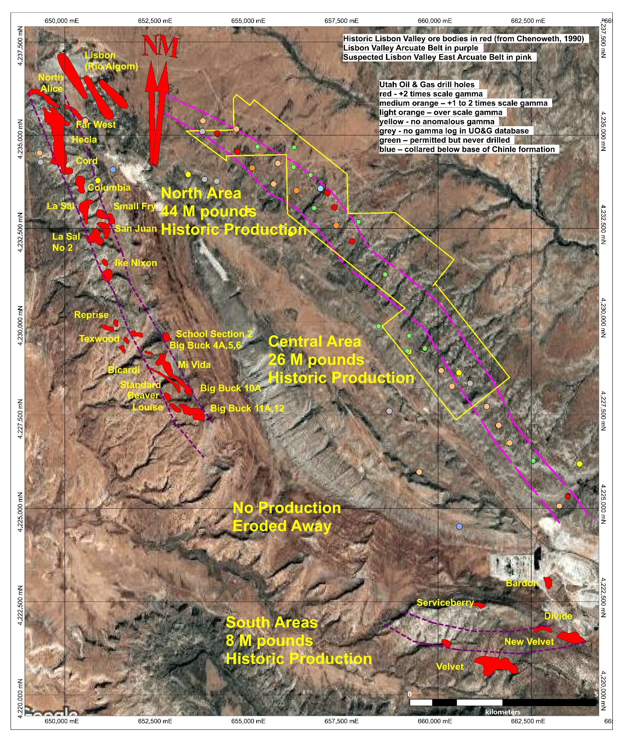

-31-

Subsequent work by Mesa Uranium and Universal Uranium in the mid-2000’s located anomalous to significant uranium grades in the Moss Back Member of the Chinle Formation on the down thrown side as well. The 2000’s through 2010’s oil and gas drilling, targeting the deeper Pennsylvanian oil bearing formations, located numerous anomalous gamma ray readings within favorable Moss Back stratigraphy, essentially mapping the suspected trace of an eastern Lisbon Valley arcuate belt.

A total of 70 drill holes are listed in the Utah Oil and Gas database, with 17 of those holes permitted but not drilled and 2 collared stratigraphically beneath the Chinle Formation, leaving 51 holes actually drilled through the Chinle over an area roughly 5 by 20 kilometres. Gamma ray readings over scale were recorded in 28 of these 51 holes, a roughly 55 percent success rate, with 12 of the 28 holes recording readings +2 times over scale and 5 of those 12 holes recording readings multiple times over scale.

DEPOSIT TYPES
(largely from Woood, 1968)

Uranium deposits in the Lisbon Valley area (Big Indian District) occur within three distinct sedimentary formations, the Triassic Chinle Formation, Permain Cutler Formation and Jurassic Morrison Formation, with the bulk of historic production sourced from the Chinle. Chinle hosted uranium is the exploration target on the Lisbon Valley East property.

The Chinle Formation uranium deposits are intimately associated with the Lisbon Valley anticline, one of a series of NW trending salt anticlines formed by the movement of salt deposits in the older stratigraphic formations deeper in the Paradox Basin. West to northwest flowing streams along each side of the anticline laid down the basal sandstone / conglomerate of the Moss Back Member of the Chinle Formation directly over Cutler Formation redbeds. Uranium mineralization is largely confined to the base of the Moss Back and also in the underlying Cutler Formation in relative proximity to the Cutler / Chinle unconformity.

An arcuate belt of some 15 miles (24 kilometres) in length by 2,500 feet (760 metres) along the southwest side of the Lisbon Valley anticline hosted a series of amoeba shaped uranium ore bodies concordant with bedding ranging in size from a few 100 pounds to 20,000,000 pounds of U₃O₈, totaling almost 80 million pounds of U₃O₈. The bulk of this production came from the northwestern 6 miles (10 kilometres) of the belt. Orebodies ranged in thickness from a few inches to 45 feet, averaging 6 feet, and ranged in size 500 to 1,500,000 tons. The edge of the ore body is abruptly defined, high-grade to no uranium in mere feet.

Uranium mineralization is hosted in a gray, poorly-sorted, fine- to coarse-grained, calcareous, arkosic quartzose sandstone containing some interbedded mudstone and limestone pebble conglomerates and some mudstone and siltstone lenses, all poorly sorted and of variable permeability. The highest-grade ore is in semi-permeable, fine-grained, sandy lenses that contain less than 30 per cent calcium carbonate as cement or as clastic limestone grains. Jasper,

-32-

smoky quartz, pyrite, and a reddish-brown or pink calcite, colored by hematitic inclusions, are common in the higher-grade deposits. There is an abundance of mudstone pebbles and coalified wood-trash either in or directly overlying the host rock.

Uraninite is the principal uranium ore mineral. Intimately associated are small amounts of coffinite and the vanadium minerals montroseite, doloresite, and vanadium clay or vanadium hydromica. Beautiful high-grade uraninite ore specimens, usually replacements of coalified wood, have been collected from many of the mines; some samples assay about 80 per cent U₃O₈. Ore minerals dominantly fill the interstices between grains of sand, but they also replace calcite, carbonaceous plant remains, and, to a lesser extent, detrital quartz and feldspar grains and other accessory minerals.

The principal detrital constituents of the quartzose sandstone host rock are quartz, limy rock fragments (calcarenites), feldspar, mica, chert, clay, and coalified plant remains. Minerals commonly associated in anomalous quantities with the ore deposits are barite, celestite, galena, pyrite, chalcopyrite, chalcocite, molybdenite, chalcedony, greenockite, and sericite.

Uranium is believed to have been indigenous to the Chinle Formation. It was subsequently mobilized or released from the siliceous glass by diagenetic processes, which started soon after deposition of sediments. The uranium was moved laterally or outward from the least permeable sediments into more permeable sandstones, as consolidation and compaction continued; and was probably comingled with vadose ground waters. Under hydrostatic forces or water of compaction forces, the solutions moved laterally through the permeable Moss Back sandstone toward points of expulsion or precipitation. At times, movement may have been rejuvenated by ground water flushing the aquifer.

Upon reaching a favorable depositional site, precipitation may have been caused by change in the pH and Eh, or by reduction in pressure, or by encountering hydrogen sulfide produced by bacterial action on carbonaceous material. The presence of an abundance of coalified plant material within the host rock and the probable leakage into the Cutler-Chinle nonconformity of natural gas or sulfur-solutions from the Mississippian oil and gas reservoirs beneath the ore belt, assures the existence of sufficient reducing agents to drop the uranium from solution.

Wood (1968) believed the original ore belt encircled the crest of the Permian anticline as a band. The southwest flank of the anticline has been thoroughly explored for large deposits. An extension of the Big Indian ore belt, similar in size and grade to the known ore belt, probably occurs in the downthrown block northeast of the Lisbon Valley fault at depths of 2400 to 2700 feet beneath the Dakota-capped surface. As of the fall of 1965, only nine holes had been drilled into the Moss Back sandstone northeast of the fault, which leaves this area as the most favorable unexplored area remaining on the Lisbon Valley anticline.

The subsequent oil and gas drilling from the 2000’s to early 2010’s appears to suggest Wood’s (1968) theory may be correct. The Lisbon Valley East property is poised to test the theory.

-33-
EXPLORATION

American Atomics Inc. has not undertaken any exploration on the Lisbon Valley East property to date.

DRILLING

American Atomics Inc. has not undertaken any drilling on the Lisbon Valley East property. All drilling completed to date on the property can be found in the History Section on this technical report.

SAMPLE PREPARATION, ANALYSIS AND SECURITY

American Atomics Inc. has not undertaken any exploration on the Lisbon Valley East property to date.

There was no data provided with respect to the Mesa Uranium Corp. or Universal Uranium Ltd. sampling procedures so therefore the author is unable to comment on them. There is also no data provided on sampling procedures with the gamma ray logs provided in the Utah Oil and Gas Database, so again the author is unable to comment on them.

DATA VERIFICATION

This project is based primarily on historical data, much of it stretching back to the 1950’s. There is no conceivable way for the author to verify the bulk geological data. That being said, the author feels comfortable with the historical production data as the data from the 1950’s to the early 1970’s was recorded by the US Atomic Energy Commission with payments made and recorded to the various mining companies and individual prospectors. While the data from the 1970’s onward was supplied largely by the mining companies themselves the amount of tailings and actual mine openings and workings provide some comfort with the production numbers.

The geology of the uranium deposits has again been recorded and documented by geologists employed by the US Atomic Energy Commission, to the standards of the day and the author is comfortable with the descriptions, observations and documentation.

The potential of Lisbon Valley East property itself is largely based on the results of the gamma ray logs from the recent historic (+ year 2000) Oil and Gas drilling. The author is comfortable with theses results as they were recorded using equipment and technology standard for the time period by trained professionals.

-34-

The author has visited the Lisbon Valley area on 2025-Jul-27, 2025-Jul-26, 2024-Apr-23, 2024-Jan-19 and 2023-Jul-21. He reviewed the Chinle Formation where it outcrops on the southwest side of the Lisbon Valley anticline and examined the area around the Mi Vida and Big Buck Chinle mines. The author visited the site of 50 of the 51 Utah Oil and Gas Drill Hole pads reviewed for this technical report in July 2025, noting the area is largely covered by unconsolidated Quaternary deposits or Burro Canyon and Dakota Formation sandstones. The target Chinle Formation lies 2400 to 2800 feet below surface.

The author is satisfied the data presented in adequate for the purposes used in this technical report.

MINERAL PROCESSING AND METALLURGICAL TESTING

To the best of the author's knowledge, there has been no mineral processing or metallurgical testing undertaken on the uranium mineralization on the Lisbon Valley East property.

MINERAL RESOURCES AND MINERAL RESERVE ESTIMATES

To the best of the author's knowledge, there no mineral reserves or resources on the Lisbon Valley East property.

ADJACENT PROPERTIES

The author is not including relevant information on any adjacent properties, other than what has been disclosed and discussed in the History and Mineralization sections of this technical report. The author discusses the lack of verification of any such data in the Data Verification section of this technical report.

OTHER RELEVANT DATA AND INFORMATION

To the best of the author's knowledge, there is no other relevant information or data to disclose with respect to this technical report.

INTERPRETATION AND CONCLUSIONS

The Lisbon Valley East property was staked targeting a suspected arcuate uranium belt on the downfaulted northeastern side of the Lisbon valley anticline, which the author believes lies at 2500 to 2800 feet below surface based on the following factors:

-35-

The North Alice ore body at the north end of the southwestern arcuate uranium belt ends abruptly at the Lisbon Valley fault, not due to a drop in grade or mineralization, but due to fault displacement, strongly suggesting uranium mineralization continued pre-fault.

The Rio Algom mine was subsequently discovered on the down-dropped footwall side of the fault, which Lahusen (1977) speculated was the actual continuation of the North Alice ore body. The North Alice orebody produced 6,000,000 pounds of U₃O₈ at a grade of 0.25% U₃O₈ (Lahusen, 1977), while the Lisbon Valley mine produced 13,000,000 pounds of U₃O₈ at the same 0.25% U₃O₈ grade (Chenoweth, 1990).

Drilling by Mesa Uranium Corp. and Universal Uranium Ltd. in the 2006 and 2007 located anomalous uranium mineralization at the base of Chinle Formation in Moss Back Member, with one highlight 3.5 foot intersection of 0.28% U₃O₈, further proving the Moss Back Member is uranium-bearing on the down faulted side on the anticline.

Oil and gas drilling on the northeast down-faulted side of the Lisbon Valley anticline located anomalous to extremely anomalous gamma ray readings in the suspected Moss Back Member in 28 of 51 hole drilled throughout a northwest trending 20 kilometre length by + 750 metre width, outlining the suspected eastern arcuate belt.

The author is not aware of any significant risks and uncertainties that could reasonably be expected to affect the reliability or confidence in the exploration information.

In conclusion, the author strongly believes an exploration program of verification drilling of the key oil and gas Moss Back gamma ray anomalies is very much warranted to commence the confirmation of a second arcuate uranium belt at Lisbon Valley, associated with the northeast side of the Lisbon Valley anticline.

RECOMMENDATIONS

An exploration program of verification drilling of the key oil and gas Moss Back gamma ray anomalies is very much warranted to commence the confirmation of a suspected second arcuate uranium belt at Lisbon Valley, associated with the northeast side of the Lisbon Valley anticline. A 28,000 foot drilling program consisting of 10 holes, focused on testing the key oil and gas gamma ray anomalies is recommended at a cost of US$3,000,000.

-36-
REFERENCES

Chenoweth,W.L. (1990). Lisbon Valley, Utah's Premier Uranium Area, A Summary of Exploration and Ore Production. Utah Geological and Mineral Survey Open File Report 186. 46p.

Dahlkamp,F.J. (2010 ). Uranium Deposits of the World. United States and Latin America. Springer-Verlag Berlin Heidelberg. 499p.

Doelling,H.H. (2004). Geologic Map Of The La Sal 30' X 60' Quadrangle, San Juan, Wayne, And Garfield Counties, Utah, And Montrose And San Miguel Counties, Colorado. Utah Department of Natural Resources, Utah Geological Survey Map 205

Hall, S.M., Van Gosen, B.S. and Zielinski, R.A. (2023). Sandstone-Hosted Uranium Deposits of the Colorado Plateau, USA. Ore Geology Reviews Volume 155. 39p. https://doi.org/10.1016/j.oregeorev.2023.105353

Henneberry, R.T (2024). Lisbon Valley Mossback Target dated 2024-Feb-09. 33p.

Henneberry, R.T (2025). Lisbon Valley Mossback Target Revision 4 dated 2025-Mar-10. 33p.

Huber, G.C. (1981). Geology of the Lisbon Valley Uranium District, Southeastern Utah. In: Western Slope (Western Colorado), Epis, R. C.; Callender, J. F.; [eds.], New Mexico Geological Society 32nd Annual Fall Field Conference Guidebook. Pp177-182.

Lahusen,L. (1977). Concept of Uranium Deposition, The Big Indian Ore Belt. Private Report 19p.

Wood,H.B. (1968). Geology and Exploitation of Uranium Deposits in The Lisbon Valley Area, Utah, In, Ridge, J., Ed., Ore Deposits of The United States, 1933-1967, American Institute of Mining, Metallurgical, And Petroleum Engineers, Inc., pp. 770-789

-37-
CERTIFICATE FOR R. TIMOTHY HENNEBERRY

I, R.Tim Henneberry, P.Geo., a consulting geologist with offices at 2446 Bidston Road, Mill Bay, B.C. V8H 1C3 and 704 – 1060 Alberni Street, Vancouver, B.C. V6E 4K2 do hereby certify that I am the Qualified Person for:

American Atomics Inc.
1500 - 1055 West Georgia Street
Vancouver BC CANADA V6E 4N7

I earned a Bachelor of Science Degree majoring in geology from Dalhousie University, graduating in May 1980.

I am registered with the Association of Professional Engineers and Geoscientists in the Province of British Columbia as a Professional Geoscientist.

I have practiced my profession continuously for 45 years since graduation.

I have read the definition of “qualified person” set out in National Instrument 43-101 (“NI 43-101”) and certify that by reason of my education, affiliation with a professional association (as defined in NI 43-101) and past relevant work experience, I fulfill the requirements to be a “qualified person” for the purposes of NI 43-101. My relevant experience for the purpose of this Technical Report is:
- 45 years of domestic and international exploration for base and precious metals, uranium and industrial minerals
- 12 years of experience in Colorado Plateau uranium exploration

I am responsible for the preparation of the technical report titled “Technical Report Lisbon Valley Property” and dated 2026-Mar-27 relating to the Lisbon Valley East Property. I visited the Lisbon Valley East property on 2025-Jul-26, 2025-Jul-27, 2023-Jul-21, 2024-Jan-19 and 2024-Apr-23 to review outcrops and data.

I have not had prior involvement with the property that is the subject of the Technical Report.

As of 2026-Mar-27, to the best of my knowledge, information and belief, the Technical Report contains all scientific and technical information that is required to be disclosed to make the Technical Report not misleading.

I am independent of the issuer after applying all of the tests in section 1.4 of NI 43-101.

I have read NI 43-101 and Form 43-101F, and the Technical Report has been prepared in compliance with that instrument and form.

I make this Technical Report effective 2026-Mar-27.

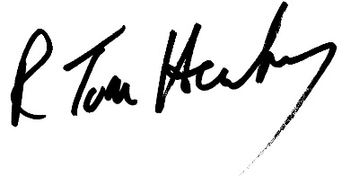 | 

R.Tim Henneberry, P.Geo
Permit to Practice Number 1001082

